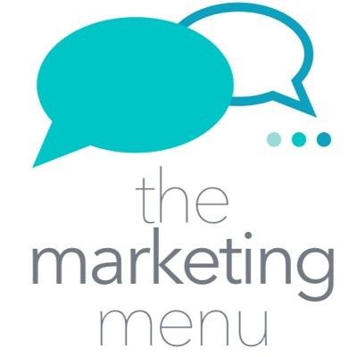
PRESS RELEASE
From: Liz Gordon for The Marketing Menu
Date: 15th March 2017
Subject: Need some no nonsense practical business marketing advice?

A new series of free business podcasts aimed at demystifying marketing terminology providing jargon-free advice and support for business will be launched on 22 March. The Marketing Menu is a collaboration between two local Hampshire and Dorset marketing agencies: Media Box Marketing & Brilliant Fish PR & Marketing.
The podcasts will be broadcast on Wednesdays every two weeks and will cover fundamental marketing issues such as creating a marketing plan, pricing, storytelling, and understanding how your customer ticks. Listeners are invited to submit questions so that future podcasts can be designed around their needs.
Nicky Matthews, from Media Box Marketing in Fordingbridge, explains the thinking behind the project: “From research we did before recording our first podcast, it became obvious that small business owners and, in particular start-ups, needed some easy-to-understand, practical tools that they really could just put into marketing practice. We’re thrilled to start this journey together and have had great feedback already about the project!”
Liz Gordon, of Brilliant Fish PR & Marketing in Poole, continues: “We wanted to get away from those podcasts that are full of Americanisms and talk about what’s really relevant to businesses to help them grow and thrive. So, we will be serving up our tasty marketing morsels in good old plain English!”
Podcasts are a great way to access information and enable listeners to choose content according to interests or categories. There are various podcast platforms, and many are designed for use with smartphones which is convenient if you are driving, walking, or working out.
To find out more about The Marketing Menu, visit www.themarketingmenu.com. Podcasts will be available to download from the website, iTunes, Blubrry, Stitcher and TuneIn.
ENDS
Photo: L-R Nicky Matthews and Liz Gordon
Media Contact
For further information / interviews / images contact:
Liz Gordon
liz@brilliantfish.co.uk
01202 747136 / 07702 808137

Editors Notes:
Nicky Matthews runs Media Box Marketing and is a Chartered Institute of Marketing marketer. A hands-on marketer with a no-nonsense approach her career includes sales, corporate business development, personal development training, marketing, and communications. As well as this she has set up and sold a mail order limited company and chaired a local, national award winning children’s charity. http://www.mediaboxmarketing.co.uk/

Liz Gordon runs Brilliant Fish PR and Marketing, a social enterprise, providing PR & marketing support for small business, charities, not-for-profits and social entrepreneurs. She is also a visiting Lecturer at the Bournemouth University and Arts University Bournemouth teaching Event Management and Public Relations. http://brilliantfish.co.uk/

