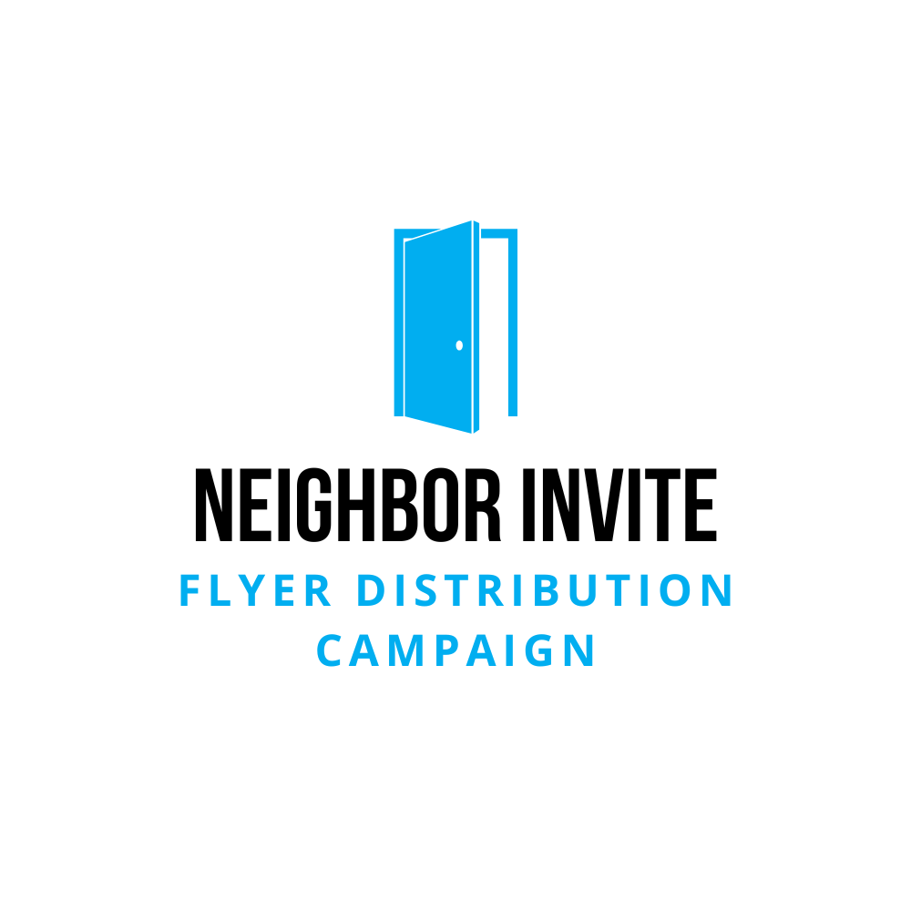 | Training Video Bullet Points

Overview
- Equip volunteers to invite neighbors through flyer distribution.
- Simple instructions with a focus on impact and purpose.

Bullet Points
Introduction
Thank volunteers for participating.
Purpose: Invite the community to church and share the good happening there.
Big Picture
Flyers are tools to help people take steps toward Jesus.
Imagine the impact of reaching 100+ homes.
Tips
Pray: Quick prayer before you go.
Timing: Mornings or evenings work best; about an hour for 70-100 homes.
Placement: Mailboxes only; skip homes with “No Solicitation” signs.
Safety: Stay hydrated, dress comfortably, and avoid headphones.
Conversations: Keep it simple—"It’s a church event flyer; can I put it in your mailbox?"
Make it Fun: Bring friends or family; kids love helping.
Wrap-Up
Deliver within the given timeframe.
Let your team leader know how it went.
Share any cool stories!
Final Encouragement
Have fun and know you’re making a difference.
This small act can lead to big things in someone’s life!

