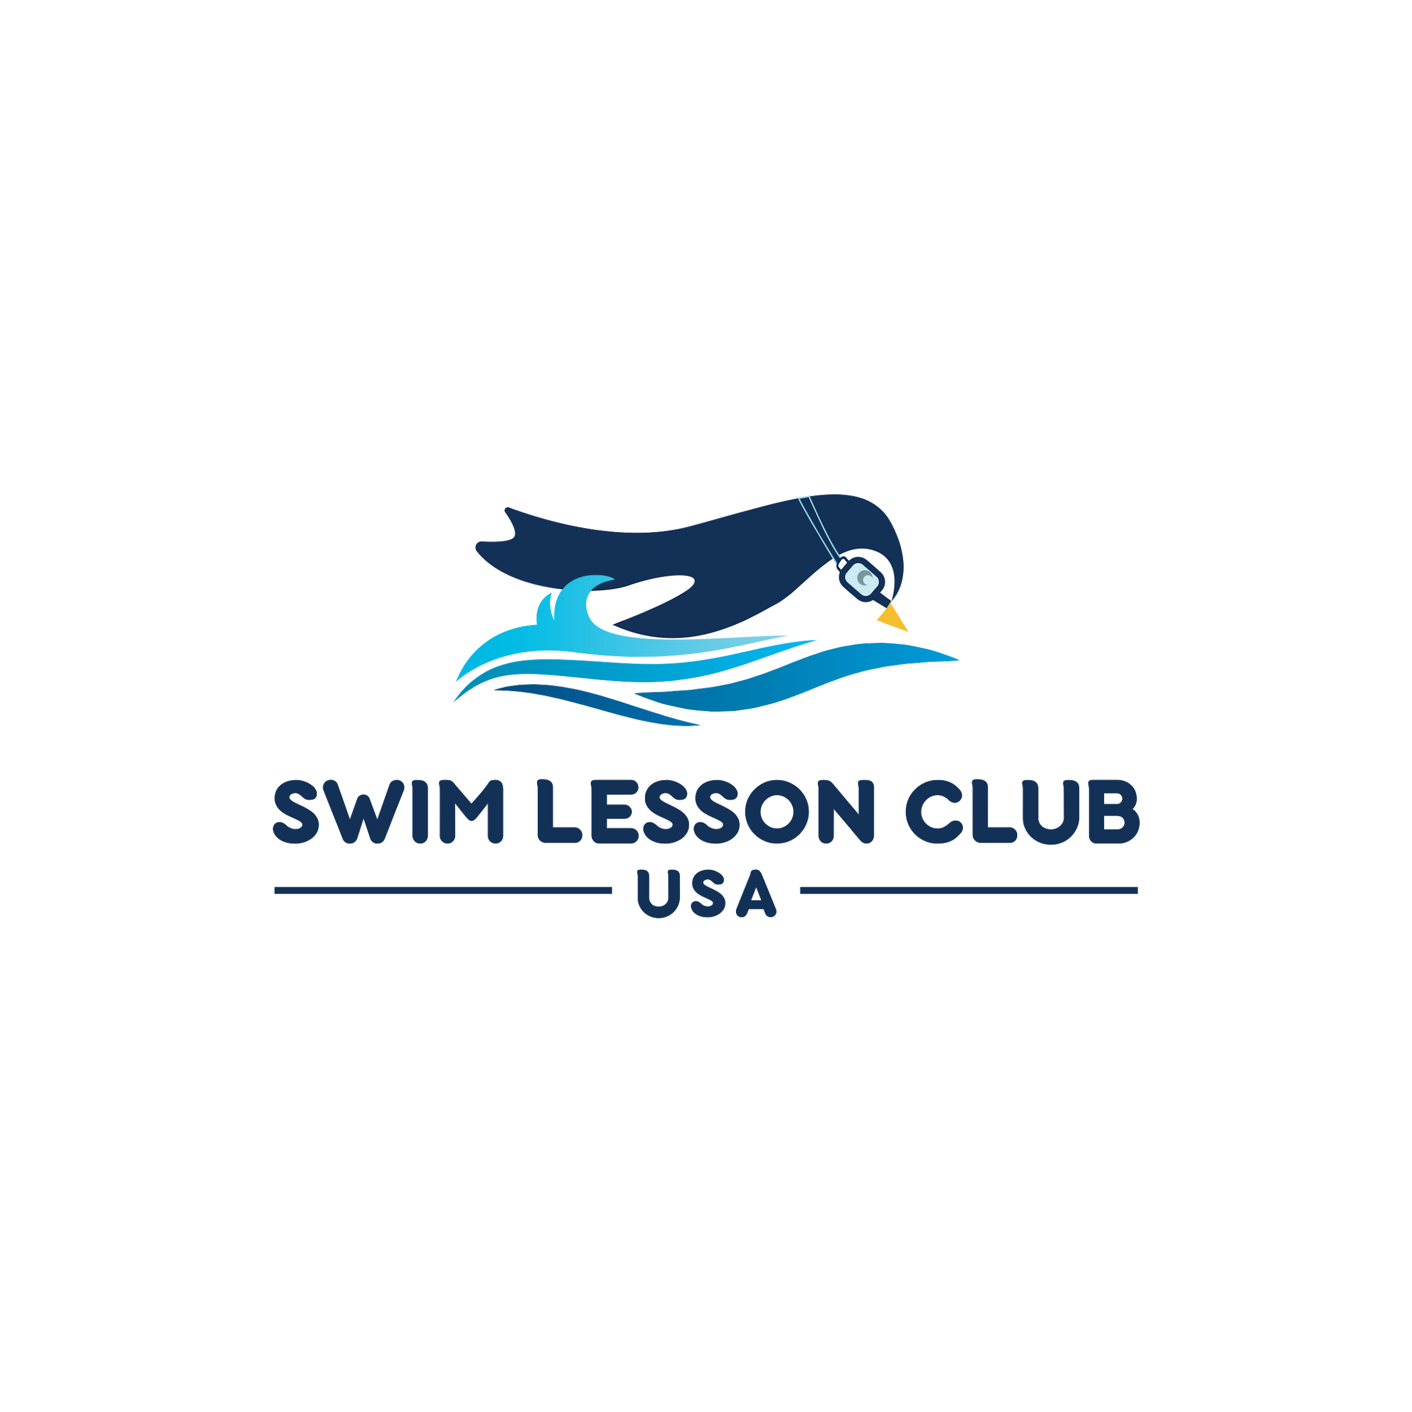
Overview -
- Swim Lesson Should be FUN
- Swimming Lessons Tools
- Class Skill outlines
- Survival Conditioning
- 6 months - 3 years P
- Beginner not afraid starting at age 3
- Beginner with Fear of water starting at age 3
- Stroke Development I (Catfish)
- Advanced Stroke Development
- Adult
- Adults with Fear of Water
- Competitive Swimming Preparation
- Engage the client and create a memorable experience for the entire family

Learning to Swim should be FUN
Each student will present with unique challenges and abilities. We want to customize all of skill exercises and interactions to fit your child's personality. We will find many creative ways to make getting water on the face and going underwater fun.
Identify, what your student needs to feel comfortable, i.e toys, splashing, pouring water, high fives, etc. Encourage your student to use their imagination. Children learn well through play and by imitating the adults in their life. Use redirection to help a child that seems to become scared all of a sudden.
Roadblock to Learning to Swim
When a child is fearful in the water it’s caused by anxiety of the unknown. The older a child begins swimming lessons the more likely they will have sensitivity to the water on the face and the buoyancy feeling.

Recommended Tools to Enhance learning
Goggles: Essential to help with comfort learning to swim
Kickboard: Helps student understand how to maintain prone streamline position while kicking.
Fins: Great for kids with fear
Noodle: Helps to instill confidence while swimming with limited support
Water Toys: Can be used as a reward or help to focus attention.

Videos -
Why Parents need to learn how to teach swim skills outside swim lessons.
- https://gopro.com/v/9JkE3ZvRKWBP

- Swim Instruction overview ages 6 months - 5 years:
https://gopro.com/v/qrg8BpdGdOPE
https://youtu.be/9bibD9Crmhs

- Parent Instruction 6 months - 3 years:
  - https://youtu.be/C-C9tt20RYU
  - https://youtu.be/SShN_ngWB9s

- How to help a child learn to breathe and exhale underwater
  - https://youtu.be/YcZWHUUzhlk

- Teaching the basics for older children
  - https://youtu.be/9bibD9Crmhs
  - https://youtu.be/UUYyfEXOuVY

- Transition from Streamline Glide into Pop Up Breathing Freestyle
- https://gopro.com/v/Rz5RNV6y905R

- Transition from Pop Up Breathing to Freestyle
  - https://gopro.com/v/7vbZ5PpvW4aG

- Freestyle
https://gopro.com/v/Rz5De3ywL581
https://gopro.com/v/rKgM001XJD0d

Swim Lesson Club USA
Fundamentals that must be taught for a student to learn to swim quickly -
Breath control -
Students must exhale or growl in order to breathe while swimming.
Buoyancy -
Students must understand how the water hold them and how to balance in the water.
Stroke Mechanics -
Students must learn how to kick properly and effectively pull the water

Swim Instructor Tips
- Never turn your back on a group of students.
- All students should be practicing when you are working with an individual child: Water pours, growling or humming in the water, pushing the water, kicking, etc.
- Continue to engage children while working with an individual student.
- Make the class super fun: Allow the students to knock you over with high fives, push the water to make bubbles, squirt, splash, anything to make the kids and the parents smile!
- Play games to teach skills and make learning fun: washing machine (gets the ears and cheeks wet, candy machine (ears and cheeks wet), hip hip hurray up and down in the water. Make your own games to encourage getting wet, pushing the water, and water on the head.
- All students should have wet hair within 5 minutes of class
- Give parents instruction as you go through the class as well to keep them engaged.
- Give parents homework to practice outside of the lessons.

Freestyle and Backstroke
- Transition into working on the freestyle as soon as the student can take pop up breaths and swim on their own without holding their breath. Many children will learn to swim with holding their breath they can’t learn the freestyle before they master exhaling underwater and taking quick pop up breaths.
- Make sure the student streamline glide is near perfect.
- Students must learn to press their ear onto the arm in order to breathe on the side. I call it a breathe button to give these students and association to push their head down. Most people lift their head of the water when breathing on the side causing them to lose the streamline position.
- Make sure the student can balance on their breathing side with their head on the arm.
- It’s helpful to isolate the breathing on the side motion and teach rolling into the water and back onto the breathing side (breathe button) without arm strokes
- The easiest way I have found to teach freestyle is to have the student focus on pressing the breath button on their arm and I will move their arms in the correct stroke mechanics. The correct arm strokes will come with development of muscle memory, therefore, working their arms helps with this development.
- Don’t allow your student to develop bad arm stroke muscle memory. Make sure elbows are pointed upward and fingers are dragging the surface of the water. It helps to have the student practice the correct arms stroke standing and hands on the side of the pool. It’s also helpful to hold their hands and help them do a modified catch up drill. I find that adults do well practicing catch up with a kickboard and kids respond better to the more manually assistance.
- Correct streamlined kicking is best practiced on back. Don’t allow thee knees or legs to break the surface to develop a true flutter kick. It’s helpful to practice flutter kick on a kickboard once the student has a good feel for it on their back.
- Once the student masters the streamlined flutter kick on their back then teaching backstroke arms is advisable.
- It helps to teach back streamline glides and wall turns along with teaching backstroke.
- Students will need to learn to growl or blow air out if their nose since a proper streamlined backstroke will certainly cause backward underwater submersions.

Skill Fundamental Tips -
- Focus on the the underwater swimming prep, proper hand holds, and cueing.
  - Hand under arms with child floating in your hands
  - Underwater submersion preparation with water pours on three. Start with a sponge and move to cups and buckets of water. Make it fun and pour on yourself.
  - Cue for underwater swimming is 1, 2, 3 then lift out of the water and under. Children under near three will respond well to the lift cue, older kids you should watch their face to make sure they are not panicking before underwater swimming. You can do partial underwater submersions (to their nose) for older children and tell them to growl or hum. Under the age of three just lift and go all the way under when they are doing well with long water pours on face.
  - Ear Dips, Growling or humming in the water
  - Water pours over face on 3 count

- Glides: Maintain a streamline position arms and legs straight.
  - We want the student to understand the buoyancy, therefore, taking on hand off the student and giving a five or helping them stroke is very helpful.
- Streamline kicking: kicks don’t break the surface and knees are not bent keeping legs straight. This can be practiced on the back.
- Backfloat (Head on instructor shoulder cheek to cheek)
- Roll from front to back (Start in glide position and roll into cheek to cheek back float)
- Wall Conditioning (Off the wall on 3 count / Humpty Dumpty Rhyme)

Age 3+
Goal: Develop favorable breathing techniques, body / stroke mechanics, safety skills
Fear of Water: All skills will take longer to master and it’s important to move slow.
Breathing -
- Exhale underwater through mouth and nose (Growl or Humm)
- Catch a breathe quickly looking up
- Pop up breathes (Underwater exhale and then look up for quick breathe then back into water)
Body Mechanics -
- Streamline Glides (Arms extended hand together and legs floating in the prone position)
- Kicking with feet in the Glide position
- Effectively pull or catch the water for max power
- How to properly recover your strokes over the water
Safety Skills
- Floating on Back (Head on instructor shoulder cheek to cheek)
- Controlled breathes for best buoyancy
- Roll from front to back
- Fall from wall and return right back to wall (Humpty Dumpty)

