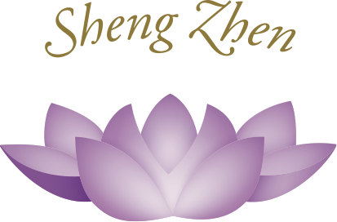

Sheng Zhen Healing Stage One

A form of Sheng Zhen Meditation

With Master Li Junfeng

Notebook

Sheng Zhen Healing Stage One

| Main Point | Notes |
| --- | --- |
|  |  |
|  |  |
|  |  |
|  |  |
|  |  |

Sheng Zhen Healing Stage One

| Main Point | Notes |
| --- | --- |
|  |  |
|  |  |
|  |  |
|  |  |
|  |  |

Questions

Do you have any questions?

Please take notes on any questions you have. These can be questions about the practice or philosophy. You can also post questions in the comment sections. We will post the answers there as well. (Questions will be answered by a certified Sheng Zhen Teacher or Li Jing or Master Li Junfeng.)