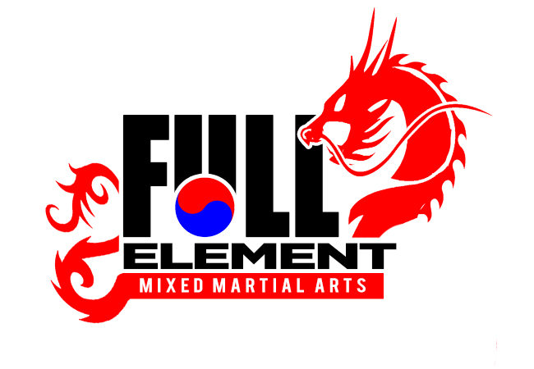 **BASIC PROGRAM**

All equipment must be purchased all at once to receive the discounted full package price of $99.99.

Belts White –

Orange Green Belt Needs

**Equipment Needs Pricing**

WHITE UNIFORM $49.99

WHITE T-SHIRT $14.99

BOXING GLOVES $29.99

NUNCHUKS $11.99

