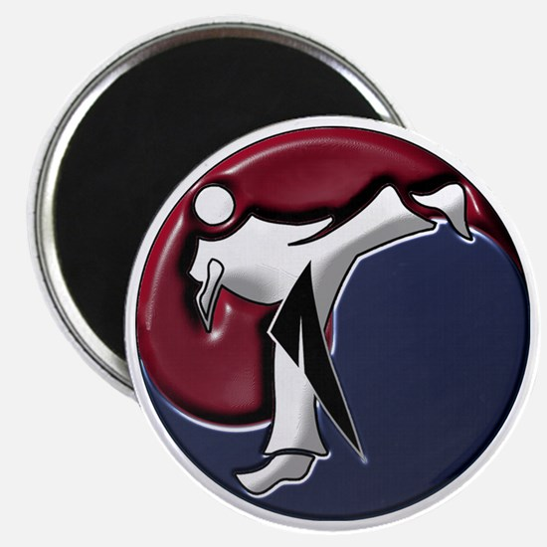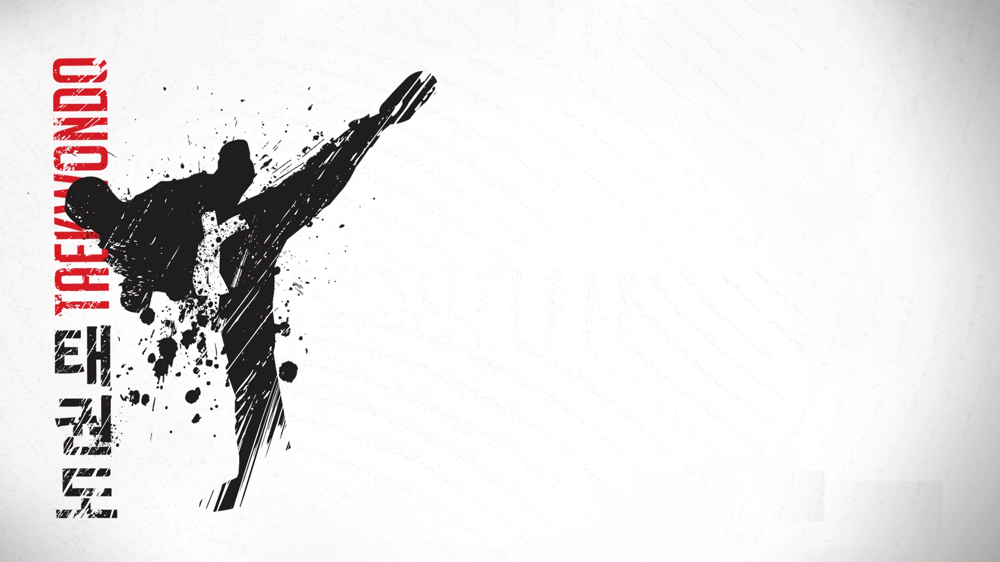

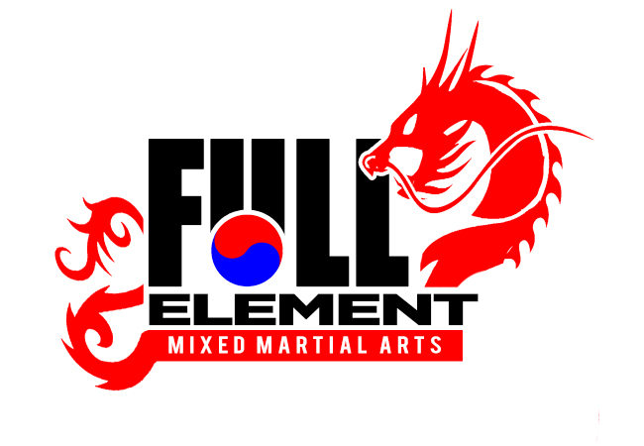 **BLACK BELT TRAINING**

**ENTIRE PACKAGE FOR $599.99.**

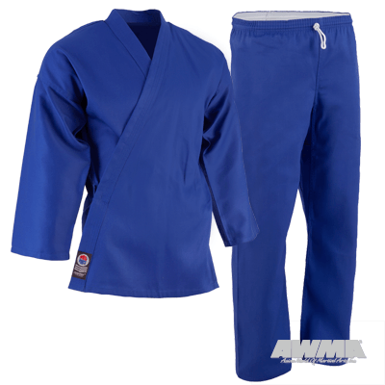

**Belts – Half Orange/Green – Purple Belt/Brown Belt**

BLUE UNIFORM $59.99

BLUE T-SHIRT $14.99

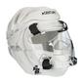PROFORCE SPARRING UNIFORM $84.99

CENTURY HANDS $39.99

CENTURY FEET $39.99

CENTURY HEAD GEAR w/ FULL MASK $119.99

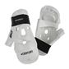DUFFLE BAG $39.99

MOUTH PIECE $4.99

LONG STAFF $24.99

KOREAN MUKGUM (WOODEN SWORD) $37.99

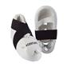KOREAN SWORD UNIFORM $94.99

BOXING GLOVES $29.99

