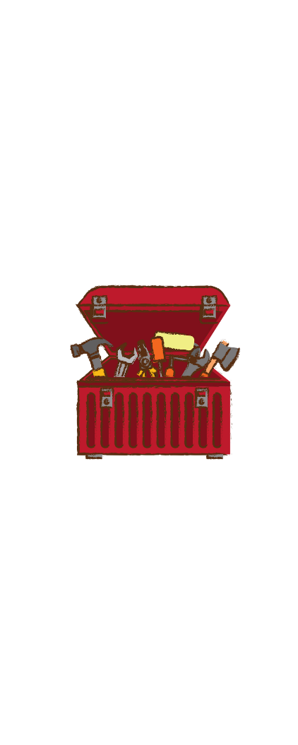

Getting Started Toolbox #4

Your Resource for Big and Small Ideas

Note-Taking Systems

This is the fourth of your first four toolboxes designed to help you begin your learning improvement efforts as “self-scientists.” Note-taking is a great place to begin because when you create an effective note system this will lead to better learning, retention, and recall of information. A better note system will yield visible and immediate improvement to learning.
This toolbox will give you useful background information to prepare you to begin coaching conversations with your child about using a better planning system.
Steps to Follow
- First, watch the lesson four video, and complete your workbook including reading the four Idea Generators.
- Read this toolbox all the way through for additional information and to gather ideas for coaching your kids on better note systems.
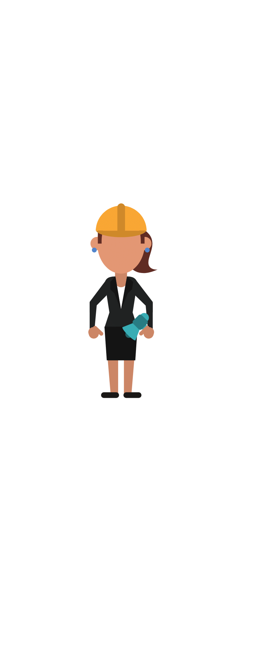
- Select an exercise you want to use from the exercises in the back of this toolbox. Then get started!

No
Maybe
Yes
Yes
Yes
Introduction
This is your toolbox full of ideas to help you start coaching better note-taking. Just like the trusty toolbox you might have in your closet or garage; it serves you as a resource. Except there are two things that are different:
- This toolbox is full of great teachable ideas in the form of exercises and mini-lessons you can use
- It won’t be used to “fix” anything; you will use it to find new learning opportunities for your child.
As a coach, you need lots of different tools to help your kid study smarter. And, of course, you need to know how to use each properly. Read through this document and get familiar with your new tools. Then start your coaching conversations to improve note-taking skills.
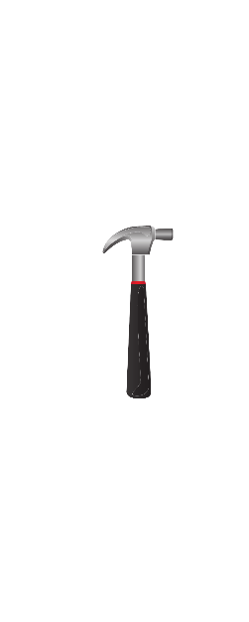
Read this for understanding and use it in conjunction with your Lesson Four video, and your Lesson Four Parent Workbook.

What’s in this Toolbox?
Your 7 Challenges page 3
Elements of Better Note Systems page 4
Quick Checklist to Audit Your Notes page 5
21 Rules for Better Note Systems page 6
The 5R Note System page 9
The Cornell Method page 10
Checklist of Ideas to Explore page 11
Try These 4 Exercises Page 12
Cornell Note Exercises
Movie Night Exercise! Page 13
The 5 Rs of Notetaking Page 13
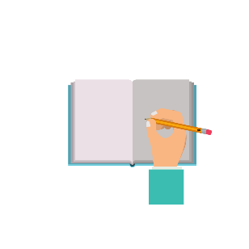
Cursive vs Computer Competition! Page 14
Jumpstart to Note-Taking - Videos Page 15

Version 4
These materials are copyright protected and designed for home use only by individual families who have signed up for this course. Commercial reuse of these materials in whole or part is not authorized. You are encouraged to share these ideas with other homeschooling families but reprinting and reproduction of them requires our written permission.

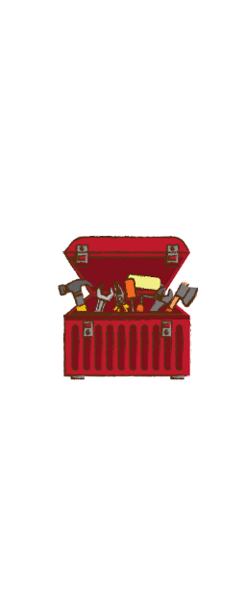
Getting Started Toolbox

Your Note-Taking System
You have identified Learning Strategies Dimension Four as one of the starting points for study improvement. This toolbox will give you useful background information to prepare for coaching conversations with your child about setting up a better note-taking system to promote better learning and memory. It also includes exercises and mini-cases to build better skills.

Your 7 Challenges
These are the challenges you will need to overcome when you attempt to improve learning maturity by helping your child to design a better note-taking system.
- Most students misunderstand the purpose of note-taking – they view it too narrowly as merely a tool for capturing and recording ideas and information. They do not use note-taking as part of a systematic strategy necessary to improve memory and recall. Notes must be integrated with other powerful learning strategies such as spaced learning and retrieval practice.
- The purpose of notes is defined too narrowly. Students don’t understand that notes should be part of a system for remembering what they learned. The purpose of effective note-taking should not be confused with creating reference material to be used later. Reference is helpful, but the primary value to the student is understanding and enabling the retention of information over a longer period of time.
- Most students do not perceive notes as being part of a system. Studies have found note-taking is most effective when notes are organized and then transformed by a series of student interactions as part of a larger process. An effective note-taking strategy requires not only effort, but a change in habits about the use of those notes. The notes are only the beginning.
- You may be challenged by a lack of motivation to change until you can help your child understand the reasons and many benefits of interacting regularly with their notes after initially recording them. You may need some “self-scientist” experiments to prove to your kids that there is lots of learning power with a better note system. (see exercises at the back of the toolbox)
- Anticipate student resistance to this change effort to improve their note systems. Remember the Dunning-Kruger effect where people who don’t know how to do something overrate their capabilities? You may likely face this. Faulty or mediocre note-taking is often self-justified by the belief we have excellent memories and therefore they don’t need to take better notes because “I can easily recall information.” But a large body of research tells us this is not the case.
- Mediocre notes look OK when viewed through short-term effects. Long-term memory gets confused with that of the short-term. Students confuse recall one day after the lesson thinking they will remember it weeks later. But memory decays rapidly.
- The problem you are solving with better notes has to do with forgetting. German psychologist Hermann Ebbinghaus discovered the “forgetting curve” in 1895 while conducted some of the first experiments on memory and recall. His insights will help you explain why notes need to be used as part of a much larger method.

The 7 Elements of Better Note Systems
What are the things you need to do to help your child acquire an expert note-taking system? Here are some of the things you will want to work on.
- You need to reframe and expand your purposes for taking notes. You will need to convince your child their notes should become part of a systematic effort of enhanced learning and better memory. This is more expansive thinking that may take a while. Emphasize the benefits to the child - including “better strategies = learn more, and study less.” This is the challenge of learning to exert a little more effort in the short term to gain a long-term advantage.
- You start with a better method for recording notes that encourages thinking about capturing key ideas and summarization. Select a method and structure it to encourage good habits. We think a “blank sheet” of paper approach is a distraction that does not encourage good habits. One great strategy to learn is the Cornell Method. Read about it here (pages 8 and 9) and understand how it works, then begin practicing it using exercise one. Then expand your child’s capabilities by adding other strategies so that you build an effective system.
- When notes are created, your strategies must consider how you will use them for near future retrieval practice and self-quizzing. For example, help you child practice using two column notes which provides the opportunity for self-quizzing by covering one column or the other with your hand. Long outline notes do not make this easy. Experiment with different methods.
- It is helpful to learn note taking strategies where new information is connected to existing information. You do this because it greatly helps memory and recall. Learn how to draw mind maps, charts, and flow diagrams. You can teach this by modeling how to do this during your instruction on a whiteboard. Or watch some videos on this.
- To gain ownership, your child should have a note system that is tailored for him. This includes incorporating good habits and other learning strategies like spaced practice, recitation, and retrieval practice. Get familiar with these learning strategies and have conversations on how to fit them into your child’s system. This is a good place for your “self-scientist” hats where you experiment with different approaches until you find the one that works best. See exercise two.
- You will need a good organizing system. Of course, this starts with simple things like file drawers and binders. At a more sophisticated level, you need to consider how paper and digital notes connect with any software used, all of this organized for quick access. We like Microsoft OneNote as a useful way to organize large amounts of information - one learning expert calls this part of his “second brain.” Promote that thinking.
- Talk about WHEN note-taking should occur. This get overlooked. It is not only when we read or sit in class. Many situations lend to taking notes. For example, skimming a chapter before reading provides an opportunity to outline key ideas and ask questions you need to answer when you read it for detail. With discovery learning, like field trips, what type of notes should be taken? Or when your child is conducting research? After a set of new math problems, how does your child summarize to remember how to do them next time?
Key Point
Of course, your child should have a system that fits his or her age, sophistication, and learning maturity. And, please remember, you want to “start small” with only a few new things to practice at first. But keep in mind your longer-term purpose here. College-level work requires managing and reviewing large amounts of new information. But you need to start somewhere. It will take you time to get there. Remember the right change method – start small – gain some successes – build confidence – add a few more strategies. Then repeat.

Quick Checklist: How Good is Your Note System?
Discover how well your notes are serving your learning. Do you have a note system that helps you learn faster? Think about this – yes, maybe, or no? The good news is this – wherever you are it’s easy to supercharge your system so you can learn more effectively. Faster learning means you can accomplish more – in less time. Start with this “audit” of your current practices and then discuss them. Begin today to find ways to improve your note system to make it really awesome!

“An audit is an evaluation or examination of something by a person or group of people used to improve it.”

My Note System Audit
Review what you do and honestly examine your note habits by answering these questions:
- Do I take notes, or do I make notes? Which better explains what I do now?
- Which is more accurate: I believe the primary purpose of making notes is to capture ideas to study them later. Or I believe the primary purpose of making notes is to improve my memory.
- Do I prefer to make notes while in class, or reading, or do I wait to do it later?
- When I make notes, do I have separate areas on the page for details and bullet points from where I record key ideas and summarize the information?
- When I read, or watch a lesson, do I write down the ideas in my own words? Or am I mostly transcribing the information using the same words?
- Am I familiar with the Cornell Note method and do I use this method often?
- I know and use the 5 R’s of note-making and use it as part of my system to learn.
- When I make notes, I try to set them up in a way so I can use them self-test later.
- Do I often draw mind-maps and diagrams in my notes to show the relationship of ideas?
- Are my notes organized by subject or project? (versus being scattered everywhere)
- My notes are organized into labeled files, binders, etc. systematically in a way so I have no problem finding and reviewing them.
- I can always find my notes quickly when I need them, usually in less than 5 seconds.
- Are my notes always filed by subject or topic?
- Do I have one dedicated area, where I keep all my note files?
- I have created a “second brain” for myself by using an app like Microsoft OneNote, Evernote, Google Keep, etc. so I can find and review key points quickly?
- I always skim a chapter and write my questions and outline before I read it in detail.
- Do I pause often to make notes while I am reading a chapter or passage?
- I always make notes to summarize the major points immediately after reading a chapter.
- During our field trips, I always make notes to capture my insights while they are fresh.
- I have a systematic method for reviewing my old notes on a regular schedule to help me remember information.
- After I solve a problem or do an experiment, I note how I did it to remember how next time.
- When I think about it, do all the different types of notes I have fit together into a systematic and organized way to promote my learning and remembering information?
Use the questions to identify at least three ways you can improve your note system. Then just do it. Then do it again in 4 weeks.

21 Rules for Better Note Systems
Use these rules to create a top-notch note-taking system to boost your learning. Carefully consider and discuss each “rule and use it to guide the development of your better system. Tackle one a day for the next three weeks and you will make great progress. As your system evolves and boosts your learning, periodically return and use these rules as a “double-check” to examine how you might get even much better.

- Transform your thinking about how you create notes and why you need them. Stop thinking about Taking Notes and think more broadly about Making Notes. Taking notes is a passive activity while making notes means creating a new structure in your own words you will use to help you remember and connect ideas. Eliminate note-taking from your vocabulary.
- Start with this mindset – it is a system you are creating. Systems should have good reasons for being and should support your goals. For example, your note system should at least:
- Save You Time  - Reduce Your Efforts | - Promote Memory  - Support Review and Practice

- Do not think of your notes as a “filing system,” this is too narrow thinking. Notes should instead serve as your memory system. You want to make notes to help you study, of course, but also to remember, and recall information. But don’t end up creating your own private Wikipedia that becomes a crutch for not learning things because you rely on finding them easily.
- You should have this one goal: the entire structure around your system must help you be more efficient at learning. If it doesn’t begin to do this, don’t waste your time – you are just tidying your desk up a bit. Recognize initially, you will face a learning curve. Power through the initial pain, and you will be greatly rewarded.
- Set your system up so it can supercharge your learning through recitation, self-testing, and spaced practice. We think the best method is the Cornell Note system which uses two-column notes with the left column containing summaries and key points. Or create fill-in exercises with answer keys on the next page. The point is to be creative when making your notes so you can interact with them now and in the future.
- A good system does not encourage rereading information - we know this to be an inefficient learning strategy. Set it up so you can find key information and ideas, and also note how information connects. Don’t make it a dumping ground for transcribed information because you will only be repeating things which is fake learning. Write down or include things that will help you study tomorrow, next week, and months from now.
- Organize information by concepts. Folders are not how the brain works. The brain works by thinking of something and then finding connections. You should be able to search and find anything almost immediately. How you organize things should not depend on the folder labels, but rather the connections or ideas that consider how you will use them. Sometimes you won’t initially see the concept but keep working and you will eventually discover it.
- The first rule of being productive? Your system must mimic how your brain searches don’t set it up as another task that you must learn. You want to remove the friction from using your notes in the future. This is a big reason why the parent should not set up the system for their kids. Help your kids make a system they own by doing it with them.
- Make it intuitive. You shouldn’t have to spend time having to think about your system – if you do you will not use it very often. It should feel natural. How does the child think and learn? Begin with this thinking. For this reason, the parent’s system should not be the child’s system.

- Poor design will age rapidly. Set up your system so it will serve your future studies. Don’t organize it to fit only today’s information. You want to be able to link future information to it. You want it to be able to grow and stretch to fit college-level work in the future. Even though you will likely start with a simple system – keep this in mind.
- Follow the 5-Second Rule. This states you must be able to find anything you are looking for in under 5 seconds. It doesn’t matter if it’s your digital or physical system — your goal is to be able to find what you are looking for fast.
- Follow the rule of ‘two actions’: if it takes more than two actions to find and complete something, you are doing it wrong. And for digital information? Same rule, different name: call it ‘two clicks’. When you are looking for a specific fact or concept, and you have to go through folder after fold to find it, then you have a broken system. Change it.
- Create a “second brain” with apps like OneNote, Evernote, Google Keep, or similar. The app you choose is where you will store information for rapid access. Paste information in the app when you know you will need to access it often. This practice will help you enable #11 your 5-second rule.
- As part of your system, create “how-to” sections where you record how you successfully have done something so you can quickly repeat it. For example, once you discover a method to solve a math problem, record the steps or create flow diagrams, and note the reasons why. Practice recording more than what – include why and how. Also note on your diagram the things you tend to forget. You want to remember the process.
- Create mind maps in your notes to connect information, this will boost your memory. Consider buying mind mapping software like Coggle, Freemind, or Imindq so you can digitally create and save the connections along with the relationships you have made in your brain. Make it easy to review so it supports your recitation practice – the key to remembering things.
- Integrate study apps into your notes so notes and how you study fit together. Digital tools are great because they can be accessed from anywhere. You can study and take notes in short bursts whenever you have a little time. For example, if you use the ANKI flashcard system (it’s great!) to study, track the daily results you achieve in your note system.
- Better learners use mnemonics to remember and help them retrieve information. You will want to capture these in your notes. Draw or create little diagrams that represent the mnemonic in your notes. These also make learning more fun!
- Develop the habit of drawing lots of symbols and flow charts that connect ideas or show how something works. The time you spend creating a diagram or graphic is also learning time for you because you are working to mentally “connecting the dots.”
- Setting your system up to accommodate the way your brain works will make it easy to start, evolve, and continue to use it in the long run. You are building something to support college-level work and beyond. This should become a life habit.
- Start your system small. A good system will take time to discover, expect and some trial and error in setting it up. But it’s worth it because a good note system will supercharge your learning and boost your retention. Trying to do too much, too fast, will likely cause you to abandon it and regress to those mindless and easy-to-do but ineffective note-taking practices. Treat it like a layer cake, lay down one solid note-making practice at a time, and get good at that, before applying another layer.
- Less is more. Systems thinking tells us the simpler the system, the more efficient. Don’t make it more complicated than it needs to be. With younger kids, start with one or two effective note practices and build on that. Don’t wait until middle-school age to begin a note system, you may end up finding yourselves fighting well-entrenched bad habits.
Thanks to Dan Silvestre, personal development guru for inspiring many of these rules.

The 5R Note System
This is a good systematic way to work with your notes. Share it. We like this five-step approach because it is an easy to understand and solid note-taking method. Although it is one of many, it is widely used, and a good one to practice using.
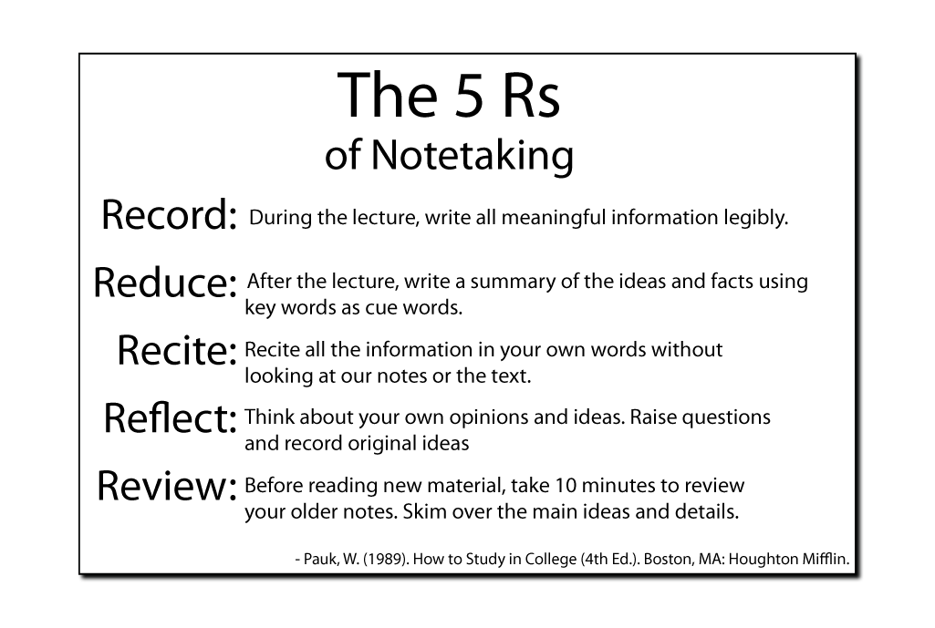
- Record: During class, or while reading, write down all important meaningful information. Do it legibly and leave spaces for adding summaries and insights later. See Cornell method below.
- Reduce: Pause as you work and/or immediately after viewing; stop to write a summary of the ideas and major points using keywords as “cue words.” Summarizing helps to:
- Clarify the meanings and relationships of ideas
- Connect ideas with existing networks of information
- Strengthen memory retention
- Recite: Frequent recitation without looking at the notes or the text is an excellent study strategy. It greatly improves the memorization of information and quickly reveals knowledge gaps and misunderstood information. (See Feynman Technique)
- Reflect: Encourage your child to think about her insights and ideas as she reads over her notes. Teach your child to write down questions, then practice answering them creatively. Ask your child to review his notebook and then share this in your weekly SPR - study planning and review meetings. Ask creative questions in your home classroom discussions and encourage your child to write papers or do a presentation at the end of a chapter.
- Review: Before reading or studying new material, encourage your child to take time to quickly review older notes. Have her present the main ideas with details. Review enhances the retention of old material while adding new material to memory.
- Pauk, W. (1989). How to Study in College (4th Ed.). Boston, MA: Houghton
When you coach and encourage the use of these five steps, you are teaching a process that you want your child to do on their own, so they must see the benefits and value of these activities. To become college-ready, methods like this should become fully-engrained habits your child willingly does without needing your encouragement.

The Cornell Method
This is the most widely used note-taking methods. A good note system encourages student interaction with the information and summarization of key ideas. As mentioned before, good notes are recorded in a way that makes them easier to review and use in the future. This lends to self-quizzing, recitation, and retrieval practice. Below is the layout of the Cornell Method.
You can make your kid’s pages by using a ruler to create these sections on a blank sheet of lined paper, or you can purchase pads of paper already set up for it.

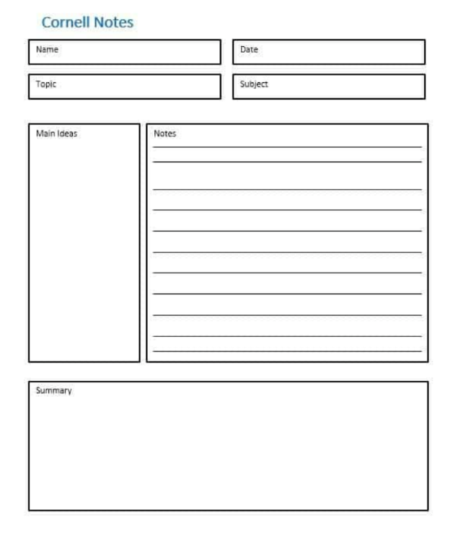
Summary at the end of the session
Key ideas and questions
Diagrams and Mind maps should be placed here
Detail in your own words – not transcription
2 columns set this up for self-quizzes

This is a proven method that is easy to learn. Watch some of the recommended videos on page 13 together, then talk about it. See exercises one and two on pages 11 and 12 of this Toolbox 4 for ideas on how to have some practice sessions while using it.

Here is another template that illustrates how the sections should be used.
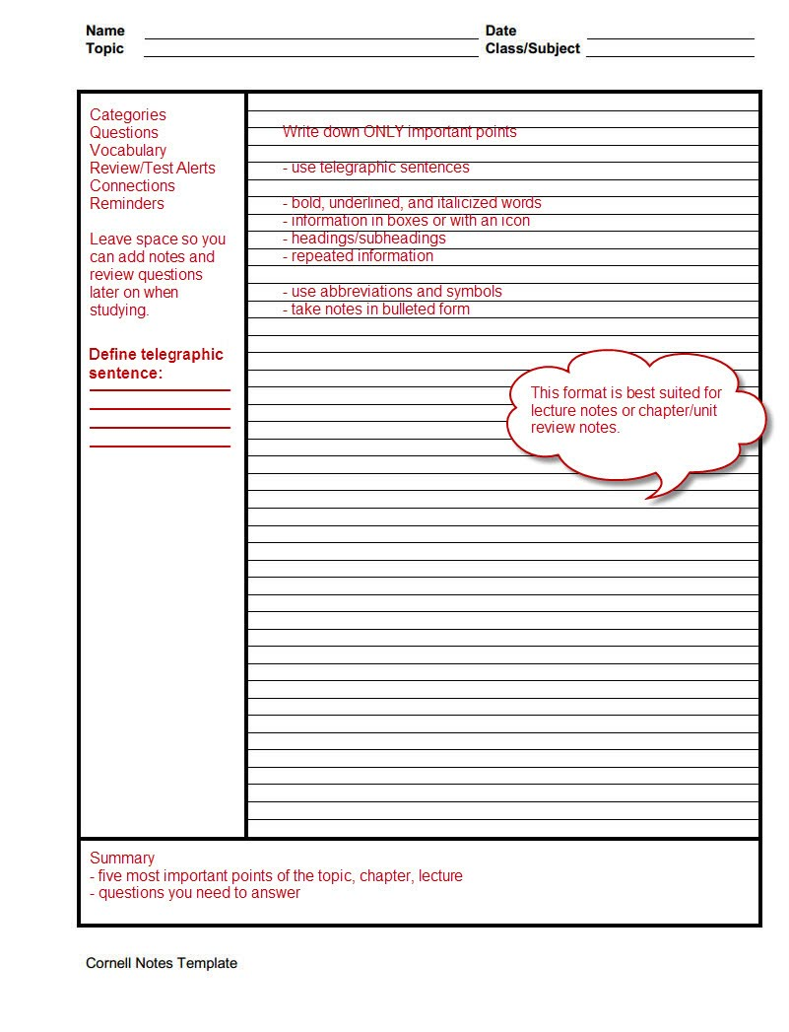
Checklist of Ideas to Explore
Explore some of these ideas and discuss them:
- Discuss the 5 Rs of note-taking and integrate this into review activities in your classroom. Practice this until it becomes a comfortable habit.
- Explain and practice using the Cornell Method for note-taking in your classroom.
- Both of you read a chapter or article on taking Cornell notes. Then compare.
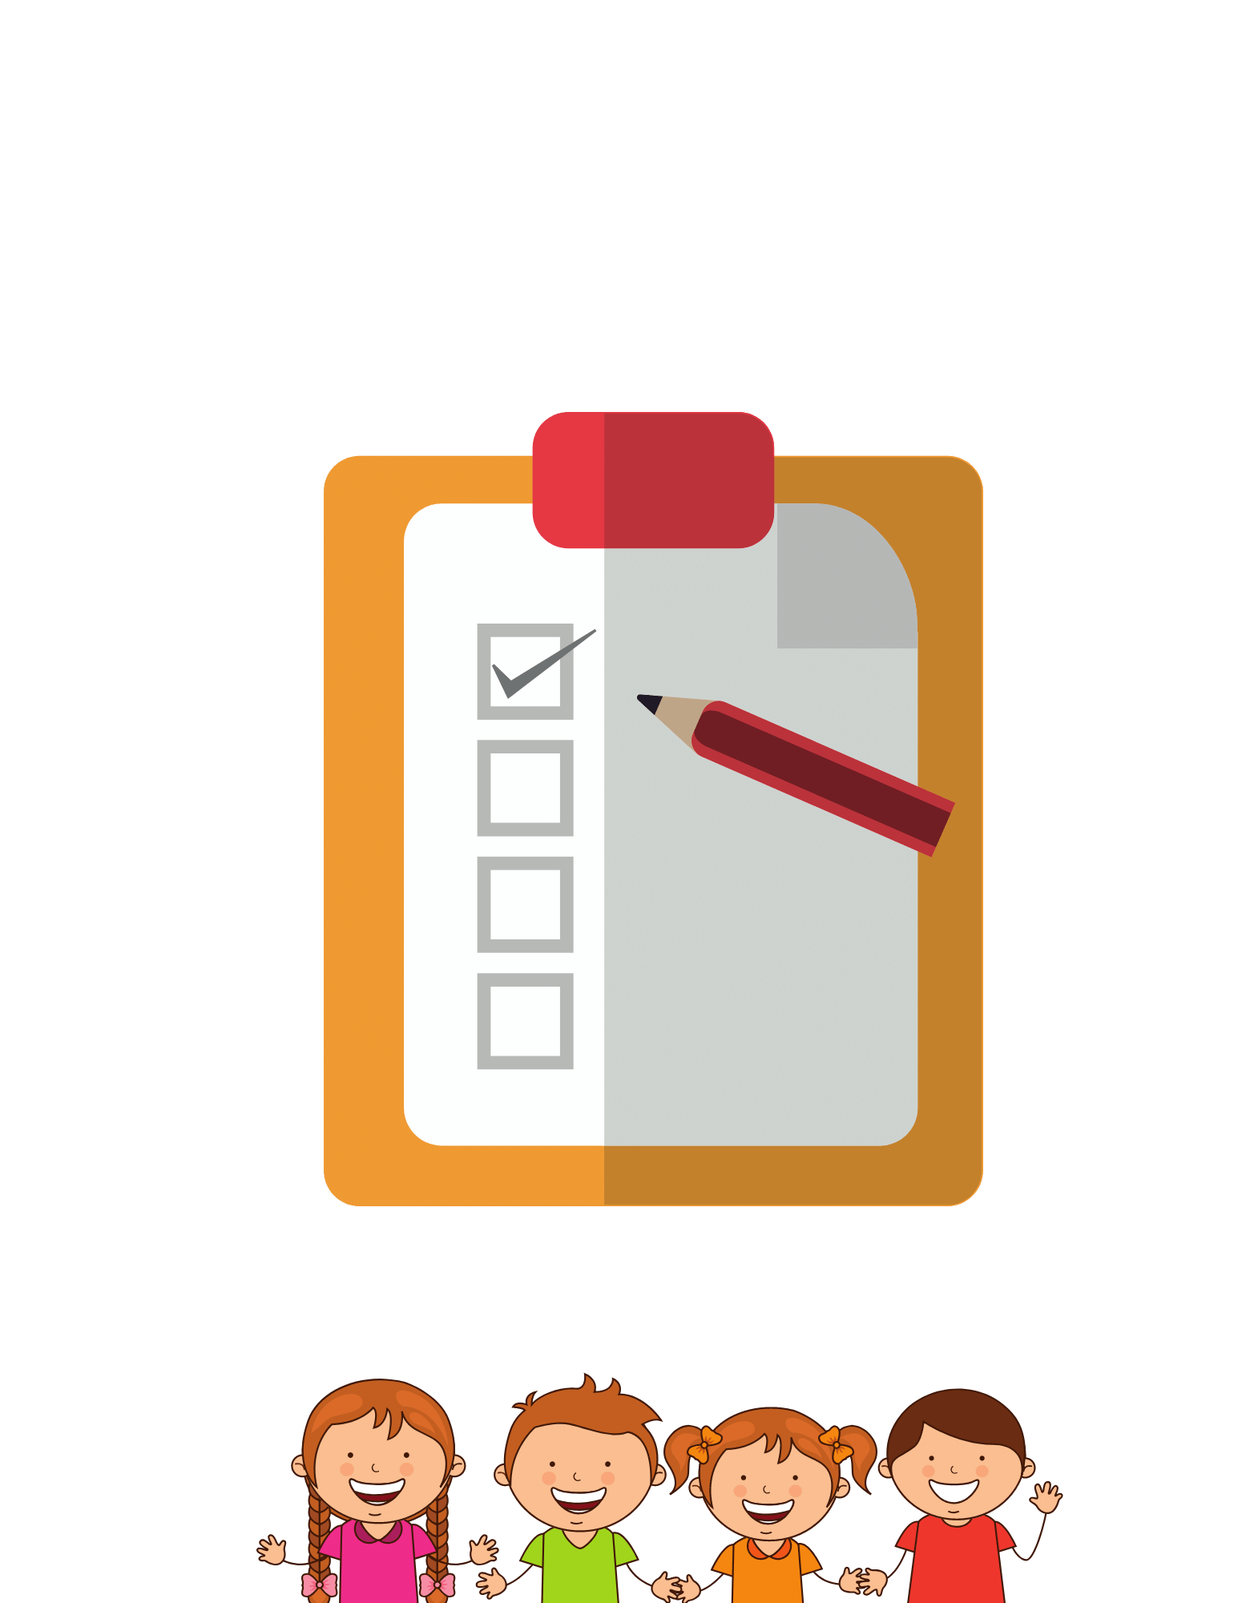
- Show your child how to take notes with mind maps.
- Set up an organizing system with the idea that it becomes your “second brain.”
- How to incorporate spaced practice and retrieval practice in your system?
Note Taking - Make it Fun!
Practicing note-taking can be easy and fun! Let’s face it, introducing fun elements to learning makes it easier to teach and practice better learning habits. We’ve developed some fun exercises for you that you can use to teach and coach better study habits that support lifelong learning. So, put on your “self-scientists” hats and try some of these ideas!
Let’s begin with a reminder of the 4 principles to making learning fun:
- Provide hands-on learning activities
- Let your child lead the way
- Be colorful and visual
- Incorporate games into the experience

Try these Exercises to Improve Note Taking
These fun exercises will help you integrate better note taking strategies into your kid’s study efforts and plans. First, watch several of the videos on note-taking and then explain the Cornell method and the importance of summarizing information in your own words. Here are some suggestions you can use to make this more creative and fun:
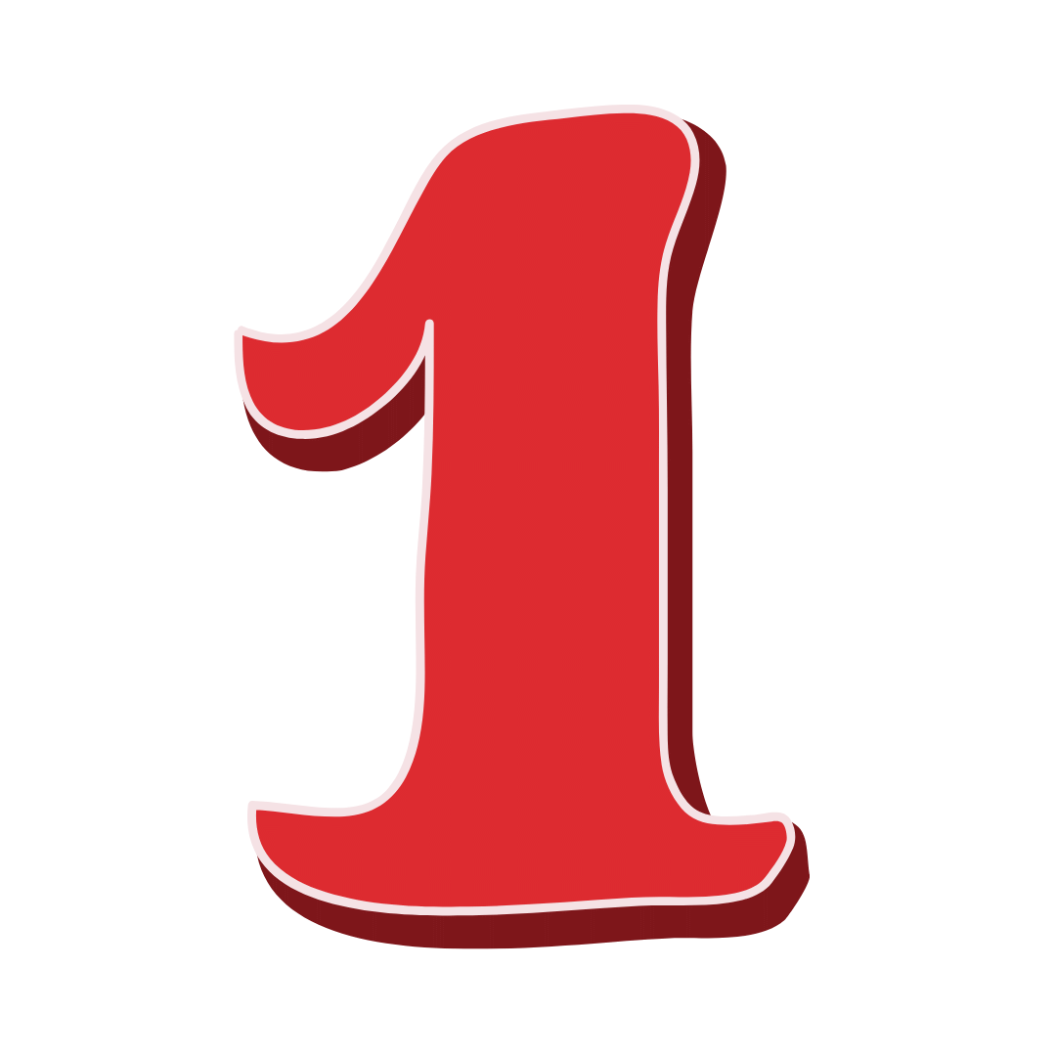
Cornell Note Exercises
Using a short story is a great way to practice this method.
For younger kids, read the story while each child takes notes using the Cornell method. For older kids, give them the reading and have them take notes as they go.
Provide copies of the Cornell note sheets to use. (you can print them from the internet or make your own with a ruler.) The kids should work independently without talking or sharing.
Emphasize the recording of information in all 3 areas – 1) bullets on the right, 3) main ideas on the left and 3) the summarization of important ideas at the bottom. All notes must be in the kid’s own words – no transcribing the points unless a quote is useful to capture a key point.
When they are ready, ask your kids, one at a time, to share their notes and explain what they wrote and why. Then compare the different approaches. Guide a discussion and ask which ideas better captured the information and why. Take the best examples from each child (everyone contributes) and list them on the board for more discussion on why these are better examples of good note-taking. Remember: this learning experience is how to capture and write better notes, not who did the best.
Begin this series with an easy and familiar story that first builds confidence, then select another more difficult and new reading to work on.
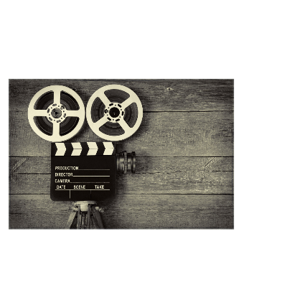
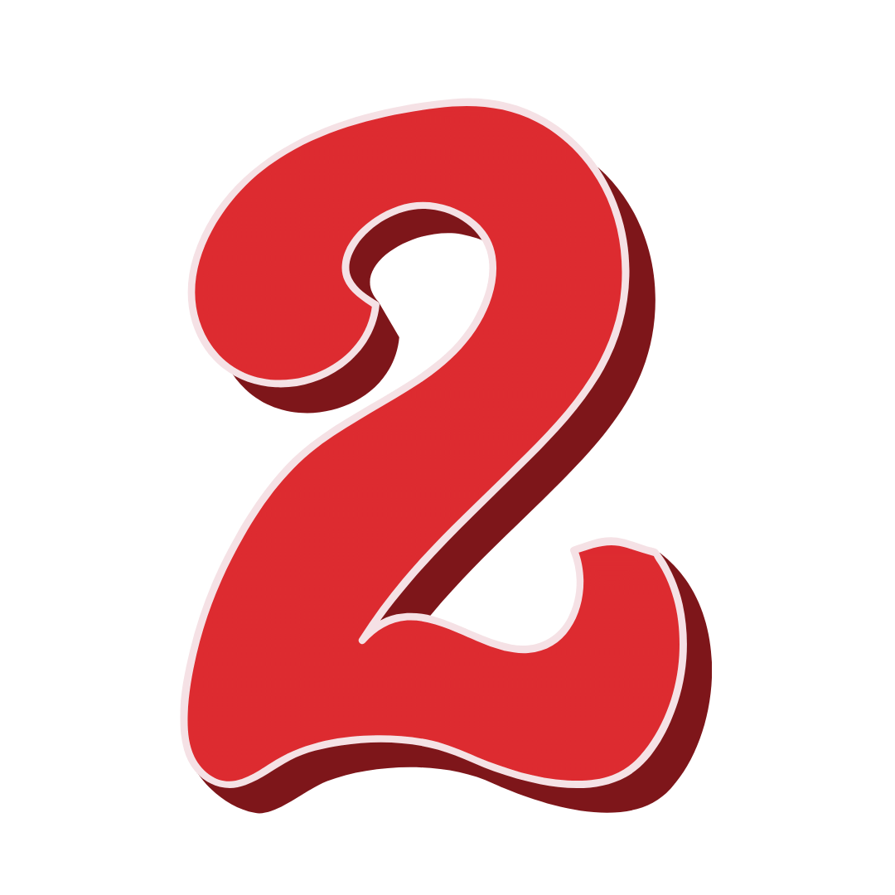
Movie Night Exercise!
Lead a fun learning exercise watching a movie you know as a study case in taking notes. This is similar to exercise one but is more nuanced and works better for teens. Movies or even TV shows can be fun training tools for note-taking, and they have lots of content you can use.
- Select an appropriate movie for the kids, from dramas and comedies, or animations, with interesting characters and plot twists.
- Next, choose a note-taking format like the Cornell method, then provide copies for each.
- Provide your kids instructions on what kind of notes to take during the entire movie. For example, ask each child to make notes on four things: 1) note what the story is about, 2) describe each of the main characters in the movie, 3) note what each did to advance the plot, and (this last one is interesting because it provokes the most thinking) 4) describe each main character’s likely motivation for doing what they did.
- Ask each to individually take notes during the movie using good note-taking techniques. No transcribing or quoting the characters – everything must be in their own words.
- Pause the movie several times at important transition points to the plot and give your kids a few minutes to time to think and record ideas, but again without discussion or sharing.
- Show the movie, and at the end give a little more time to improve and summarize their notes. This is an important step to better memory.
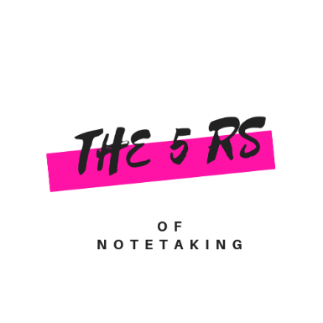
- After a break, hold a roundtable discussion where each child will share and explain his notes. Take one criterion at a time so you can explore who did a better job of capturing information and why. Don’t emphasize right and wrong – focus on getting better.
- Compare ideas and extract insights on how to take better notes. Remind them that good note-taking improves memory and recall of information.

The 5 Rs of Note-taking
Build a lesson around this method. You will want to read and become familiar with this technique before starting the exercise. Pick new material on a subject that your kids like. You can use lecture, as the model suggests, or substitute independent reading of a chapter. But use content that is important so your time doing this is well spent.
Next, walk your kids through the 5-step process, explaining each step one at a time. Remember this system is not only a note-taking system, but a process for learning. You can personalize this for each kid, or you can use the same material if your kids are of similar ages and interests.
Remember this is an exercise in note-taking and how to learn faster. Allow 20-25 minutes for each step, followed by a short break. You can spread this out over 3 days if you wish.
Record - The first step is to provide the lecture while your kids take notes using a system like the Cornell method.
Day 1
Reduce – On their own, have them write a summary of ideas and facts from their notes and memory. Process and improve these notes through a discussion. Compare ideas produced by different kids.
Recite – Let the kids go into private spaces and practice recitation to improve memory and recall.
Day 2
Reflection – Get the kids together and have another discussion on the material, this includes some review, but also trying to find new insights. Give them a little time to think about the last step.
Review – In a group, roundtable and have each kid present the main ideas from the original lecture in their own words. This should not be from reading their original notes. You can have them speak from bullets on note cards, or better, ask them to work from memory.
Day 3
Debrief - In the last step, have a conversation on how well this approach worked to improve your understanding and enhancing memory and recall. Talk about the implications of this to other homework and studies.

Cursive vs Computer Competition
If you are ambitious and you have lots of kids, try this “self-scientist” experiment which duplicates the methods used by scientists during their research.
Explain the purpose of the experiment. Choose a short reading that has details, facts, and/or numbers that will need to be captured by the kids.
- Assign to each kid to one of two groups either A) the cursive handwritten group, or B) the laptop group using their own system. Set this up as a fun competition where you will compare results and discuss ideas. The more kids - the better the energy.
- Arrange the room so each child cannot see the notes of the others. Start your experiment by reading the short story at a slow but deliberate pace. This is not a lecture, so your kids can’t ask questions. Their job is to take notes each using only the designated method.
- When you call out “stop!” they must close their notes and then take a short break. This allows a little time for the forgetting curve to kick in. You want this to occur.
- Next, without looking at their notes, have each child take out a blank sheet of paper, and individually list as many details and facts as they can remember from the story. You will do this with both groups to see which method produced better memory.
- After every kid has finished, place the notes a big table where everyone can see the completed sheets of paper. Organize notes by Group A cursive on one side, and those by Group B computer on the other. Discuss which resulted in better memory.
Put on your self-scientist hats and try to discover what happened and why.
The science tells us the kids that took cursive notes should do better. Did you get this result? If not, discuss why, and consider repeating the learning experiment.

Get a “Jumpstart” to Better Note-Taking

Turn these videos into mini-lessons about better note-taking. Watch them and have conversations about what you will do differently at home to build a better system.

- This is a useful reference on the fundamentals of note-taking. Use it as a reading then have a short lesson discussion on what we should do differently.
https://learningcenter.unc.edu/tips-and-tools/effective-note-taking-in-class/
- Here is an excellent 6-minute video to watch with your child on the Cornell Method.
Cornell Method.
- How to use the Cornell method to take information from an encyclopedia. The Life of a wolf. A very deliberate demonstration that provides good examples.
https://www.youtube.com/watch?v=JPSmXRIlyS8
- This is a basic video on the Cornell note method:
https://www.youtube.com/watch?v=Lu7WM_fmR1k
- Merging Cornell Method and Sketchnoting from Verbal to Visual
https://www.youtube.com/watch?v=pZgMpjjgCRA (10 minutes)
- A good overview of note-taking in class. Emphasis on Cornell notes. 6:38 min.
https://www.google.com/search?source=hp&ei=niMBXbHuMIn_-gS0k5rIDA&q=how+to+take+good+notes&oq=how+to+take+good+notes&gs_l=psy-ab.12..0l10.7198.12179..12672...1.0..0.90.1841.23......0....1..gws-wiz.....6..35i39j0i131j0i131i67j0i67.dFOXMAtbYD4#kpvalbx=1
- Good general tips on setting up a note-taking system. (7 minutes)
https://www.youtube.com/watch?v=njstk6xlrh0
- Mind mapping video with the author of this strategy.
https://www.youtube.com/watch?v=u5Y4pIsXTV0
- A 3-minute animated video on mind mapping.
https://www.youtube.com/watch?v=kCKZ75VDaSI

After these exercises turn your new knowledge into a better system for your child!

