# **List of Values**

Brene Brown - https://brenebrown.com/resources/living-into-our-values/

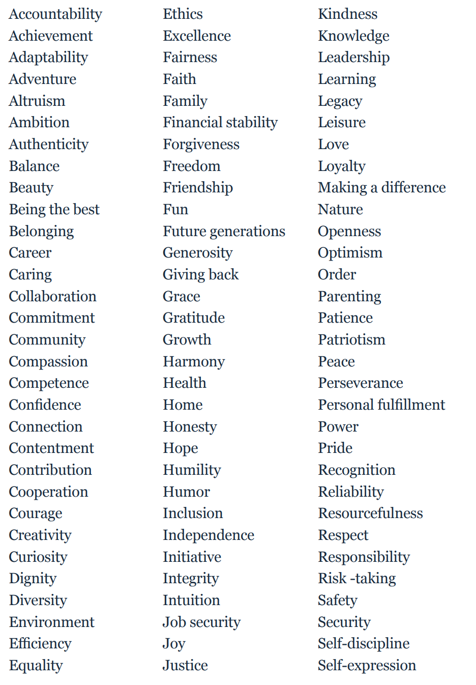

# **Self-eulogy**

Imagine it is your funeral. Who would you want to be there?

Who would you like to speak at your funeral?

What would you like them to say about you and your life?

What values can you extract from that?

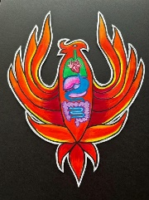

# **Ikigai**

Reflect on your childhood memories. What brought you the most joy?

Throughout your life, what events brought the greatest changes? What were your greatest achievements? What affected your emotions the most?

What brings you happiness daily? When do you feel most fulfilled?

What makes you smile and feel joy when you think of it?

What do you do that never leaves you feeling bored?

When are you most curious and eager to explore?

What and when do you feel most moved?

What would you like to change in your life now?

What would you like to change in the future?

What makes you feel alive?

What would you do if you had all the money in the world?

What would you keep doing even if the rest of the world failed to understand why?

What skills come naturally to you? What do people approach you for in asking for help?

What kind of work environment would you like to be in? Are there any volunteering opportunities in your field of interest?

Can you make a decent living doing this kind of work in the long term?

# **Deathbed Exercise**

Top 5 regrets of the dying – Bronnie Wade

**I wish I'd had the courage to live a life true to myself, not the life others expected of me.**

**I wish I hadn't worked so hard.**

**I wish I'd had the courage to express my feelings.**

**I wish I had stayed in touch with my friends.**

**I wish that I had let myself be happier.**

# **Odyssey Plan**

Scenario 1

What does your life look like in the next 5 years at your current trajectory?

Scenario 2

What does your life look like if Plan A cannot happen?

Scenario 3

What does your life look like if money and time were no object?

Map/draw/scribble it out

