Worksheet # 2 - Transitioning through Change

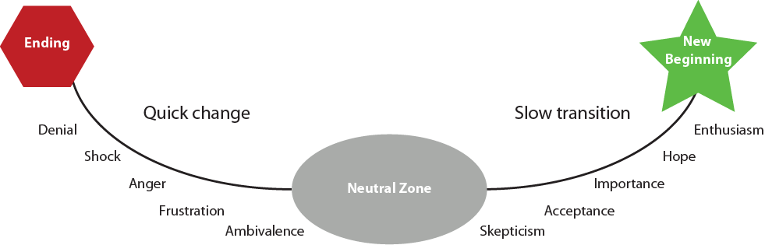
Emotions
Emotions

In the process of transitioning through change, you must to let go of how things used to be and go through a time of uncertainty and confusion in order to arrive at a place where there’s a new beginning. To let go of the old and to enter a time of uncertainty can be difficult, but this time in the “Neutral Zone” is the necessary bridge you must go across in order to arrive at a new beginning.

Notes:

Worksheet # 2 - Transitioning through Change
(page 2)

Three Phases to Transitioning through Change

PHASE #1:

PHASE #2:

Four reasons “The Neutral Zone” feels terrifying:

Worksheet # 2 - Transitioning through Change
(page 3)

Four reasons “The Neutral Zone” feels exciting:

Remember:

Going through the “The Neutral Zone” takes _________________.

PHASE #3:

