PROTOCOL : Reimprinting
‘’Wanting to remain what we used to be prevents us from becoming what we are !’’
Objective : To find and integrate new beliefs to experience new emotional and behavioral choices related to recurrent patterns of the same kind.
Technique : on a timeline, find again the imprints of programming and/or structuring situations (most of the time between conception and age 7 or 8). Bring resources that were missing at the time and integrate them until the present moment – and project them into the future. P identifies a recent situation where an inappropriate reaction coming from a limiting belief manifests.
- Set up a timeline. P steps on the timeline and associates himself with this situation.
- P steps backward on the timeline until he no longer feels the unpleasant sensation (in some cases we will go back to the time of conception)
- Once the sensation disappears, make P move forward again until the sensation starts to come back (Pivotal Point – Seen in Level 1 Training)
- How old are you ?
- What is happening ?
- With whom are you ?
- etc.
- Dissociate P and ask him what he would need at this moment :
P finds a positive experience where he felt this resource and associates himself with it.
P then symbolizes it with a color, object, and sends it to the moment before the programming event on the timeline.
- P stands on the timelime again, associated with the resource (color, symbol…) and T verifies the new feeling related to the event.
- Once it tests positive, P goes back to the present.
- Bridge to the future.
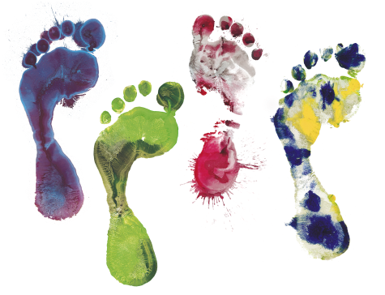(Institut Ressources Belgique)

