Tarot, Death & Grief - Lesson 3

Case Studio
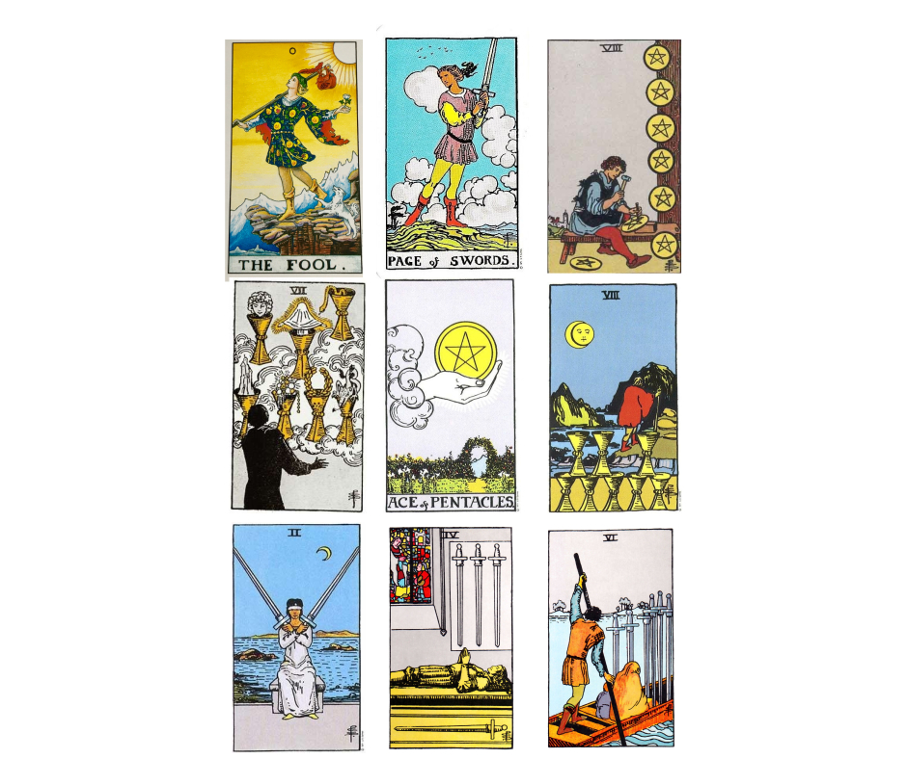

Henrietta is a querent who has come for a general reading for the next 6 months. You're using a 9 card spread that dedicates each row to the past (foundation, root of the issue) , present and future of the situation, while the columns add information to the reading.

- What do you see in here?
- Is there something unusual in the reading?
- Are there any indicators that there is actual death involved in the reading, aside from the 4 + 6 of Swords?
- If so, what are they?
- Does it look like an avoidable thing, or is it informative? Do you think Henrietta is aware of this?
- How would you interpret this reading?
In case you can't see it clearly, the cards are, from left to right and from top to bottom:
The Fool - Page of Swords - Eight of Pentacles

Seven of Cups - Ace of Pentacles - Eight of Cups

Two of Swords - Four of Swords - Six of Swords

*** When you are ready with your answers, please see the video in the section “Case Studio Interpretation”***

