ATTACH THESE PAGES AFTER THE WORKBOOK FROM THE
PLAN THE PROJECT COURSE

^{v1.0}

The BA Guide’s Business Analysis Process
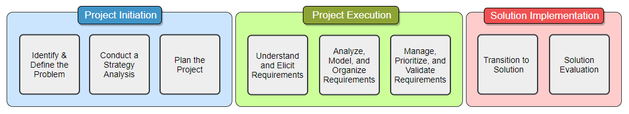

What are the main concepts taught in this course?

Understanding Requirements

What are requirements, what do they look like, and why are they important?

Are there significant differences between Project vs Product Requirements? If so, what are they?

What are the four levels of requirements and what makes each of them unique?

What are the most popular types of requirements and how are they defined?

is the process of extracting or drawing forth information.

To elicit or to gather, what is the difference?

Complete the Venn diagram to show the correlation of Customers to Stakeholders to Users.
And then provide some explanation or examples of each

Your Stakeholder’s Perspective

What are some of the common expectations project stakeholders have?

Why are meeting these expectations important?

What are some of the common fears project stakeholders have? How can you overcome them?

Requirement Process
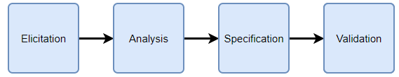

Requirement Elicitation Process

What is the Requirement Elicitation Process and why is it important?

Breaking down the Requirement Elicitation Process

Step 1:

Step 2:

Step 3:

Step 4:

Useful Supporting Documents

What is a Parking Lot, how is it used, and why is it beneficial to your project?

What is a Term Glossary, how is it used, and why is it beneficial to your project?

Requirement Elicitation Technique: Document Analysis

Prepare Notes:
- Finalize the topic and scope of the elicitation

- Identify any additional participants

- Analyze participants –
Language, expertise, location, and influence.
- Determine logistics –
Session (length, time, location, resources)
Participants (communication channel, roles)
Resources (equipment, tools)

- Establish the end result / output

- Find and create supporting documents

- Define elicitation notes medium

- Provide stakeholders with their invitation –
Topic, goals, logistics, and end result for the session

- Identify and evaluate risks

Conduct Notes:

Confirm Notes:

Best Practice Notes:

Requirement Elicitation Technique: Observation

Prepare Notes:
- Finalize the topic and scope of the elicitation

- Identify any additional participants

- Analyze participants –
Language, expertise, location, and influence.
- Determine logistics –
Session (length, time, location, resources)
Participants (communication channel, roles)
Resources (equipment, tools)

- Establish the end result / output

- Find and create supporting documents

- Define elicitation notes medium

- Provide stakeholders with their invitation –
Topic, goals, logistics, and end result for the session

- Identify and evaluate risks

Conduct Notes:

Confirm Notes:

Best Practice Notes:

Requirement Elicitation Technique: Brainstorming

Prepare Notes:
- Finalize the topic and scope of the elicitation

- Identify any additional participants

- Analyze participants –
Language, expertise, location, and influence.
- Determine logistics –
Session (length, time, location, resources)
Participants (communication channel, roles)
Resources (equipment, tools)

- Establish the end result / output

- Find and create supporting documents

- Define elicitation notes medium

- Provide stakeholders with their invitation –
Topic, goals, logistics, and end result for the session

- Identify and evaluate risks

Conduct Notes:

Confirm Notes:

Best Practice Notes:

Requirement Elicitation Technique: Questionnaire / Survey

Prepare Notes:
- Finalize the topic and scope of the elicitation

- Identify any additional participants

- Analyze participants –
Language, expertise, location, and influence.
- Determine logistics –
Session (length, time, location, resources)
Participants (communication channel, roles)
Resources (equipment, tools)

- Establish the end result / output

- Find and create supporting documents

- Define elicitation notes medium

- Provide stakeholders with their invitation –
Topic, goals, logistics, and end result for the session

- Identify and evaluate risks

Conduct Notes:

Confirm Notes:

Best Practice Notes:

Requirement Elicitation Technique: Interview

Prepare Notes:
- Finalize the topic and scope of the elicitation

- Identify any additional participants

- Analyze participants –
Language, expertise, location, and influence.
- Determine logistics –
Session (length, time, location, resources)
Participants (communication channel, roles)
Resources (equipment, tools)

- Establish the end result / output

- Find and create supporting documents

- Define elicitation notes medium

- Provide stakeholders with their invitation –
Topic, goals, logistics, and end result for the session

- Identify and evaluate risks

Conduct Notes:

Confirm Notes:

Best Practice Notes:

Requirement Elicitation Technique: Requirement Workshop

Prepare Notes:
- Finalize the topic and scope of the elicitation

- Identify any additional participants

- Analyze participants –
Language, expertise, location, and influence.
- Determine logistics –
Session (length, time, location, resources)
Participants (communication channel, roles)
Resources (equipment, tools)

- Establish the end result / output

- Find and create supporting documents

- Define elicitation notes medium

- Provide stakeholders with their invitation –
Topic, goals, logistics, and end result for the session

- Identify and evaluate risks

Conduct Notes:

Confirm Notes:

Best Practice Notes:

Understand and Elicit Requirements - Final Thoughts

What is the difference between eliciting requirements in an Agile versus non-Agile project?

What is the best way to become more fluid and knowledgeable in elicitation?

CONGRATS ON COMPLETING THE
UNDERSTAND AND ELICIT REQUIREMENTS COURSE!

Find more courses in this Business Analysis Process Series at:
www.thebaguide.com/baprocessseries

