

**Name: Date:**

**Teacher:**

English: Reviewer

**Noun: Talks about Person, Place, Thing and Animals**

**Examples:**

|  |  |  |  |
| --- | --- | --- | --- |
| **Person** | **Place** | **Animals** | **Things** |
| Teacher  Girl  Nurse  Father  Student | Hospital  Police station  Library  Theatre  Barber  Restaurant | Dog  Chicken  Catfish  Ladybug  Cow  Iguana  Cat | Toothbrush  Pencil  Computer  Eyeglasses  Shoe |

**Adjectives:** ***An adjective is a word that describes a noun or pronoun such***

***as person, place, thing, or idea.***

***An adjective can tell color, size, shape, taste, odor, texture,***

***sound, number and weather.***

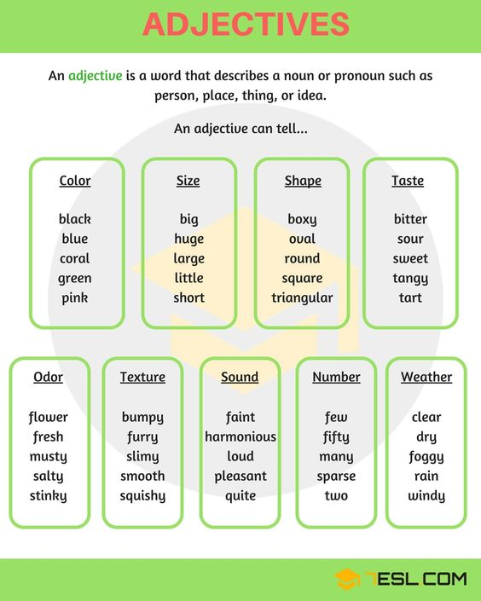



Verb: A verb is a word that shows actions, motions, doing something, or states of being.

|  |  |  |
| --- | --- | --- |
| Past | Present | Future |
| Played  Jumped  Cleaned  Walked | Play  Jump  Clean  Walk | Will play  Will jump  Will clean  Will walk |

Examples:

I can **do** anything.

She can **save** the world.

She **will save** the world.

She **saved** the world.

**Verb to be: is am are**

Examples:

1. You **are** funny.
2. He **is** funny.
3. I **am** funny.
4. She **is** funny.
5. They **are** funny.

**Collective Nouns** – describe a group of people,things ,animals

|  |  |  |
| --- | --- | --- |
| **Group of people**  A cloud of students  A circle of friends  An army of soldier  A flock of tourists  A crowd of peaple  A choir of singer  A dynasty of kings  A band of musicians  A troupe of artists | **Group of things**  Bunch of flowers  A flight of stairs  A deck of cards  A basket of plums  A string of pearls  A bouquet of flowers | **Group of aniamals**  A litter of puppies/kittens  A flock of birds ( pigeons, parrots seagulls, sheep)  A colony of ants  A herd of cows/buffaloes, elephants,Donkeys  A pack of dogs/ wolves  A swarm of bees  A school of fish /sharks  A pride of lions  Lodge of beavers  Flocks of geese ,pinguins  Bed of snakes |

*teacher will review them on short and long vowels based on what they have copied.