# Momentum and Newton’s Laws Mini-Quiz

**Q1.**

When hitting golf balls long distances, golfers *follow* *through* with the swing. Doing this increases the time for which the club head is in contact with the ball.

The figure below is a stroboscopic photograph of a golf swing. The images were taken at equal time intervals.

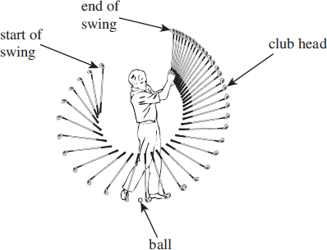

(a)     Sketch, on the axes below, how the speed of the club head varies with time over the whole swing.

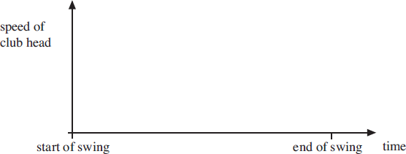

**(2)**

(b)     Explain in terms of the impulse acting on the ball the advantage to the golfer of following through with the swing.

.................................................................................................................................................................

.................................................................................................................................................................

.................................................................................................................................................................

**(2)**

(c)

The club head is in contact with the ball for a time of 180 μs. The mass of the club head is 0.17 kg and that of the ball is 0.045 kg. At the moment of contact the ball is at rest and the club head is moving with a speed of 35 ms–1. The ball moves off with an initial speed of 58 ms–1.

(i)      Calculate the average force acting on the ball while the club head is in contact with it.

**(2)**

(ii)     Deduce the average force acting on the club head due to its collision with the ball and explain your answer.

.................................................................................................................................................................

.................................................................................................................................................................

.................................................................................................................................................................

**(2)**

(iii)    Explain why it is not possible to transfer all the kinetic energy of the club head to the ball.

.................................................................................................................................................................

.................................................................................................................................................................

.................................................................................................................................................................

.................................................................................................................................................................

**(2)**

**(Total 9 marks)**

**Q2.** (a)     State the difference between vector and scalar quantities.

.................................................................................................................................................................

**(1)**

(b)     State **one** example of a vector quantity (other than force) and **one** example of a scalar quantity.

*Vector quantity* ...............................................................................................

**(1)**

*Scalar quantity* ...............................................................................................

**(1)**

(c)     A 6.0 N force and a 4.0 N force act on a body of mass 7.0 kg at the same time. Calculate the maximum and minimum accelerations that can be experienced by the body.

**(3)**

**(Total 6 marks)**

**Q3.** The diagram below shows an electric two-wheeled vehicle and driver.

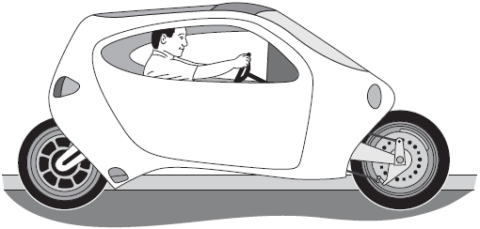

(a)     The vehicle accelerates horizontally from rest to 27.8 m s–1 in a time of 4.6 s. The mass of the vehicle is 360 kg and the rider has a mass of 82 kg.

(i)      Calculate the average acceleration during the 4.6 s time interval. Give your answer to an appropriate number of significant figures.

**(2)**

(ii)     Calculate the average horizontal resultant force on the vehicle while it is accelerating.

**(2)**

(b)     State and explain how the horizontal forward force on the vehicle has to change for **constant** acceleration to be maintained from 0 to 27.8 m s–1.

.................................................................................................................................................................

.................................................................................................................................................................

.................................................................................................................................................................

.................................................................................................................................................................

**(3)**

**(Total 7 marks)**

# Extension Question:

Water of density 1000 kg m–3 flows out of a garden hose of cross-sectional area 7.2 × 10–4 m2 at a rate of 2.0 × 10–4 m3 per second. How much momentum is carried by the water leaving the hose per second?

**A**        5.6 ×10–5 N s

**B**        5.6 × 10–2 N s

**C**        0.20 N s

**D**        0.72 N s

# 