Lesson 13: Sending Emails using Mail Merge
Mail Merge is a good tool to use when you need a fast and efficient way to communicate with people. A small business for example, may want to send out letters as part of a marketing campaign. A non-profit organization may need to do fundraising campaigns throughout the year by sending out emails to their donors.
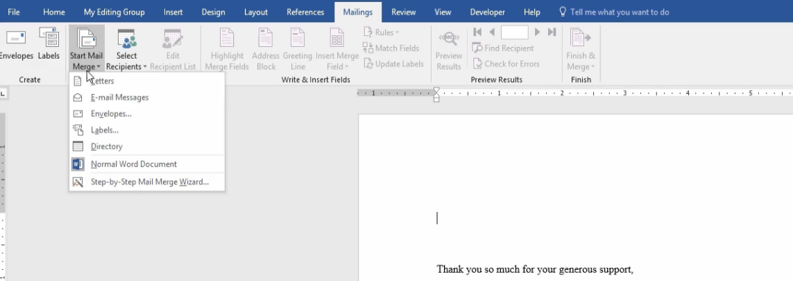
- To start the Mail Merge, click on the Mailings tab on the Ribbon and click on the Start Mail Merge down arrow. Choose Email messages
1

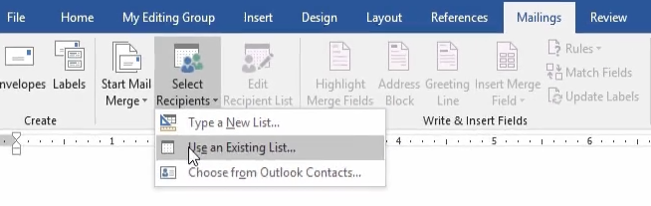
- Under Select Recipients, choose Use an Existing List
2

- Locate the file that has the list of Email recipients (i.e. on a flash drive, C drive, etc.), then double-click on the file. The Select Table dialog box will appear. Double-click on the file you want to use, which in this case is the Employee List.
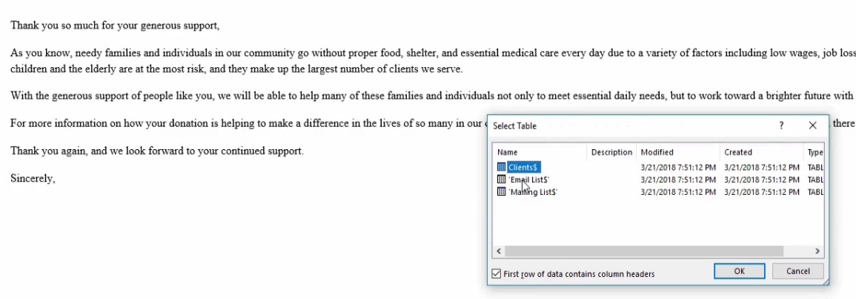
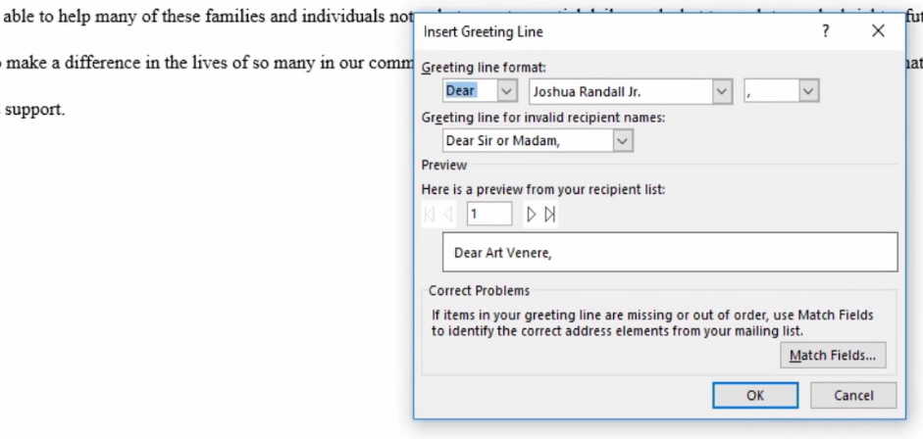
4. Click on the Greeting Line button; a dialog box will appear.
3
4
4
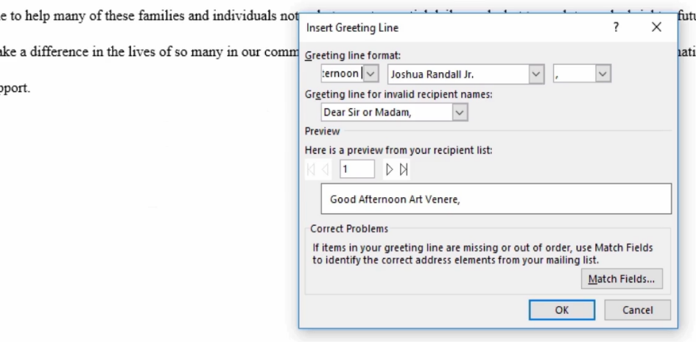
- Under Greeting line format, change the word “Dear” to the words “Good Afternoon”; press the Space key.
5
5
- Use the second drop-down list under Greeting line format to choose how the person will be addressed (i.e., First name only, first and last name, etc.). For this example, let’s choose First name followed by a comma. Under “Preview, you can click on the right and left arrows to see how the Greeting will look. Click OK.
6
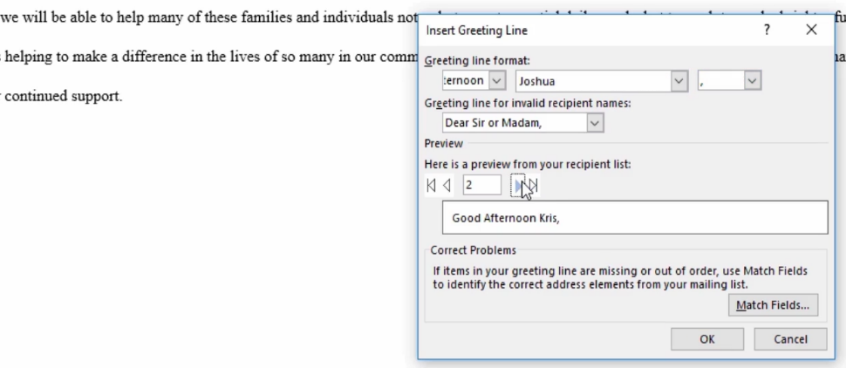
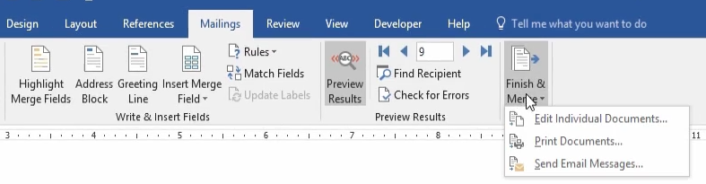
- You can see the Preview Results button at the top of the ribbon to see how the email is going to look by clicking on the left and right arrows. Click on the Finish and Merge down arrow in the Finish group.
7

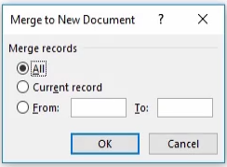
Here you have the option of creating a new Word document that merges the email messages with each name on the list. merging the email message with the names within the Word document by choosing Edit Individual Documents. You can now choose to merge all of the records, the current record or choose specific records from the list. If you choose to merge all the records and then click OK, you’ll see the greeting followed by the message pasted onto multiple pages. This is a good option to choose if you want to copy and paste each individual message into your email applications (i.e. Outlook), rather than having Word automatically send them to Outlook for you.
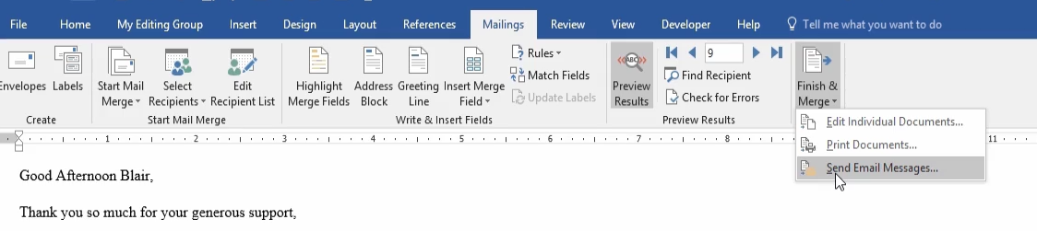
- To send the email message right away, Click on Send Email Messages.
8

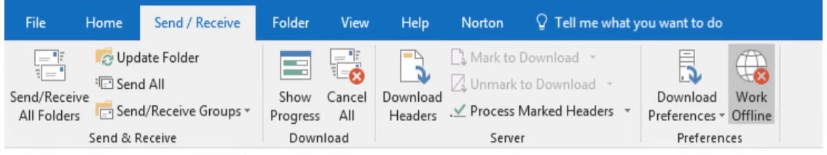
- Keep in mind that messages sent to Outlook will automatically be sent to the recipients without any kind of confirmation message or warning. If you just want the messages to be kept in your Outlook folder and not sent, you must go to the Ribbon, click on the Send/Receive tab and click on Work Offline in the Preferences group.
9

