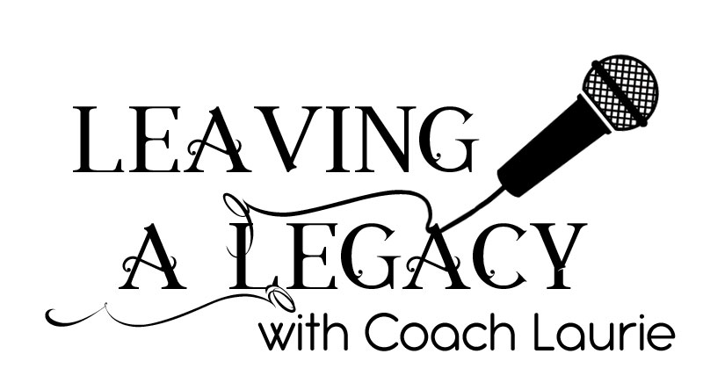

Who Am I Serving?
You have something to share and you know you are feeling like it is time.
Who do you serve, by sharing your thing?
Who will be enriched by what you want to share?
Or….Do you just want to podcast but don’t have an idea?
What is your passion?
What is your soapbox?
What do you know how to do that you can share with others using a podcast?
What do you want people to know?
If you don’t have an idea of what you want to say,
you can investigate getting hired as a podcaster for someone who
Has something to say but doesn’t want to say it themselves.
Can you commit to a weekly podcast?
For at least 12 weeks?
So, if not, maybe now is not the time.
If you are going to talk about “your thing” …

Here are a few tips.
Don’t script it unless you are a FANTASTIC reader.
Pick one topic per episode.
Will you be talking?
Are you interviewing people?
Do you have passion that will keep you going for at least 12 weeks?
How long do you want your podcast to be? 10 mins? 20? 30?
How many podcasts do you listen to?
Now that you are getting clear on what you want.
Make a list of 12 things you want people to know, about life or what you love.
Just You: Scroll down past interviewing
INTERVIEWING:
Make your list of guests
Many Podcasters use zoom for interviews.
Have an opening, and a closing.
Start with your mission, and the bio of the guest.
When you say hello, they will say something like Hi how are you.
Don’t answer that. People aren’t really interested in that. Just move to the first question.
If you know that person and want to reminisce a bit, make it very short and sweet.
Have your interview questions ready for the show?
When you interview ask the questions from your heart.
If you want to know the answers so will your listeners.
Listen to your guest and if some question rises that is not on your list
go with your heart and ask.
During the podcast you may have some awkward moments don’t worry you can edit those out.
At the end ask maybe a question you want to ask every guest, Brene Brown does this on
her podcast.
Ask them where we can find them for more information.
(don’t say “our listeners” many podcasters do. Personally,
it makes me feel like I don’t matter, it is grouping me in with other people).
Listeners want to feel like you are talking to just them.
Another pet peeve, some podcasters do this but it really grates on me.
“You Guys” it makes me feel like they are up here on a stage and I am a peon
Down below. Just say you. You are talking to one person.
Trust me, 30 plus years in radio, people want the intimacy
of feeling like they are your only listener.
Take away:
Intro you
Intro guest
Keep banter if any keep it short and sweet
Ask the questions
Listen to your guest
Don’t be afraid to ask a question not on your list
Ask where we can find the guest on the internet
If they have a book or record, ask them to tell us where to get them.
Thank you
Outro about your podcast.
Voila.
Always remember, it is your show. If you have decided it’s 20 minutes, then the guest doesn’t get to change the rules.
If you have an agenda, then you do you, they don’t get to steer the boat.

JUST YOU
Pick at topic for the episode.
You can have an outline if that helps.
Intro (Probably pre produced)
Start talking.
Don’t say “I want to talk to you about” just talk to them about…
You will say “um” and “you know a lot”.
It’s okay, you can edit it out.
Don’t ramble, get to the point and move to the next.
Some people end with a “Take Away”.
Tease your next episode.
Next week we are talking about ….
Some people end with thanks for listening or until next time.
There you go.
If this is something you feel excited about then you are on the right track.
Creating your intro and outro
You want your intro to be informative, qualifying, short and sweet.
Hi there, I’m…..
And this is …. (name of podcast)
Qualify yourself, ex: I am a coach, mom, teacher, deaf….
I am excited/Passionate/crazy …. About…….
Your hope for the listener (without calling them the listener)
My hope for you…
What I hope you will get out of this is….
It can be serious, funny, just informative.
Put your music under it so all you have to do is add it each time to your finished product.

Outro,
Thanks for listening,
I’m …
With … Name of podcast,
Some people like an out like Fitz in the Morning the Bull 98.9
“No ones better than you”
I say I’m coach Laurie and this is enough.
Even shorter than your intro.
Put music under it and it will be ready to add each episode. (if you want)
Before the outro at the end of the podcast you might want to “tease” next weeks episode,
See you next week when we talk about…..
Also after you have a few in the can, you can add, share with a friend…
You can help us by giving us a 5 star rating and review.

