**Ninth Grade Age of Revolutions**

**The French Revolution**

By Dr. Chris Deason for Earthschooling

Copyright The BEarth Institute, Inc.

**Instructions to Students**

*(Be sure to do the activity “G9 – Philosophical Introduction to the Age of Revolutions” before you do this part of the lesson block.)* Understanding the French Revolution willhelp us to acknowledge our own turbulent times in the 21st Century. The reading below is extensive and complex but well worth the time spent with G9 learners such as yourselves who understand the complex world in which live.

**Hegelian Dialectic Formula**

Steiner advocated a form of ethical individualism based on Johann Wolfgang Goethe's worldview, in which “Thinking…is no more and no less an organ of perception than the eye or ear. Just as the eye perceives colors and the ear sounds, so thinking perceives ideas." Ultimately, Steiner taught that there are no essential limits to human knowledge. A new stage of Steiner's philosophical development is expressed in his *Philosophy of* *Freedom*. Here, he further explores potentials within thinking: freedom, he suggests,can only be approached asymptotically and with the aid of the "creative activity" of thinking. Thinking can be a free deed; in addition, it can liberate our will from its subservience to our instincts and drives. Free deeds, he suggests, are those for which we are fully conscious of the motive for our action; freedom is the spiritual activity of penetrating with consciousness our own nature and that of the world, and the real activity of acting in full consciousness.

This includes overcoming influences of both heredity and environment: "To be free is to be capable of thinking one's own thoughts – not the thoughts merely of the body, or of society, but thoughts generated by one's deepest, most original, most essential and spiritual self, one's individuality."

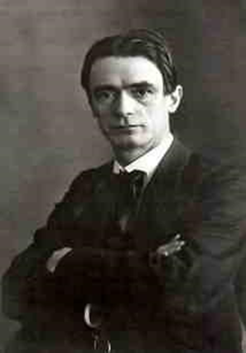

Public Image of Rudolf Steiner

Rudolf Steiner emphasized that the natural scientific mode of thinking came to the fore in the modern age, during the first half of the nineteenth century. We have only to think of men like George Wilhelm Friedrich Hegel August 27, 1770 – November 14, 1831).

Steiner continues, “in their days, men still had faith in the spirit and believed that the spirit would help them to fathom the world of nature; they believed that nature was in some way directed by the spirit.” Hegel regarded freedom or self-determination both as real and as having important ontological implications; self-determination and soul he believed were one in the same.

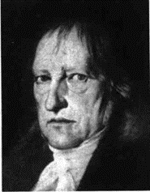

Public Domain Image of George Hegel

Hegel proposed that change, evolution, and history were forms of a cyclical dialectic processes now labeled the Hegelian Dialectic. The Hegelian process of change in which a concept or its realization passes over into and is preserved and fulfilled by its opposite...development through the stages of *thesis, antithesis, and synthesis* in accordance with the laws of dialectical materialism...any systematic reasoning, exposition, or argument that juxtaposes opposed or contradictory ideas and usually seeks to resolve their conflict...the dialectical tension or opposition between two interacting forces or elements."

Hegel's dialectic often appears broken up for convenience into three moments called "thesis" (in the French historical example, the French Revolution), "Antithesis" (the terror which followed), and "synthesis" (the Constitutional state of free citizens). The Hegelian dialectical formula: A (thesis) versus B (anti-thesis) equals C (synthesis).

It’s important to penetrate and understand Hegelian consciousness as it relates to the French Revolution. We can all penetrate the world with our soul and consciousness. We are all sorcerers and sorceresses that have the power to use our will to change the world for better and worse. We can choose, with our own will what we will do and become. With our will we create the world and educate ourselves. We are free to sink down to the lowest animalistic level or raise ourselves to the gods’ highest spheres.

**Activity I: Dialect Activity**

You’ve just read about George Hegel and the Hegelian dialectic formula. You need to compose a paragraph explaining the thesis, antithesis, and the synthesis of the French Revolution as you read or following the reading below. For example: If (A) my idea of freedom conflicts with (B) your idea of freedom then (C) neither of us can be free until everyone agrees to be a slave.