Wound Measurement Program Outline
- Review standard measuring techniques
- Review standard terminology for measuring
- Discussion of Wound Bed, Periwound and Surrounding Tissue descriptions
- Wound Drainage Documentation
- Review standard guidelines

Complete the narrated powerpoint instruction followed by a post-test and survey for CEU credit 0.5 contact hour provide by NYS approved provider Wound and Therapy Seminars LLC

Objectives
After course completion, the learner can expect to:
- Demonstrate how to measure a wound for standard documentation
- Explain differences in wound bed presentations
- Plan to avoid common mistakes
- Identify recommended universal measuring guidelines

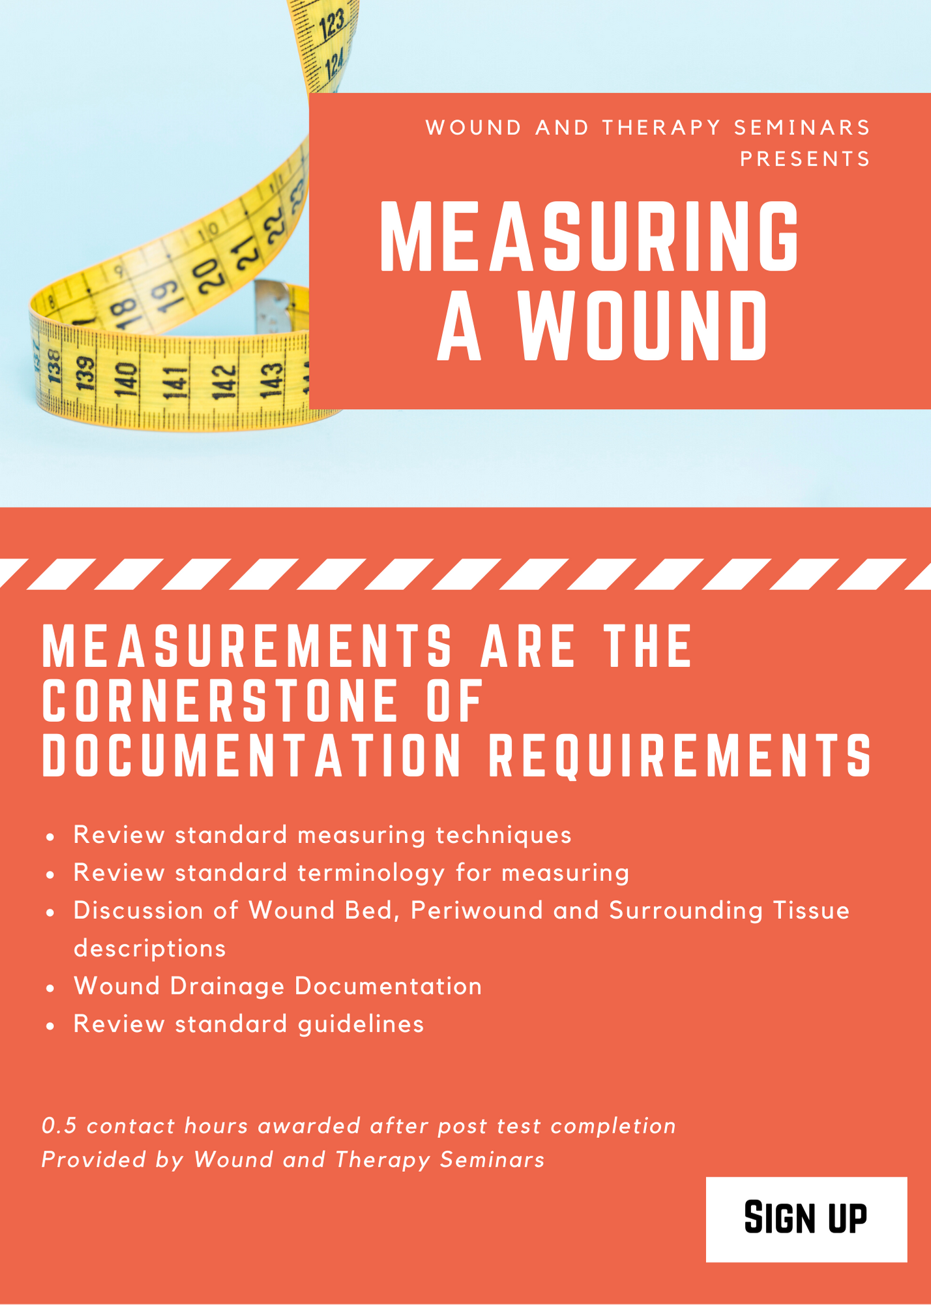

HEATHER CASCIO FLEXER, PT, DPT, CWS

betterwellnesspt@gmail.com
Linked In Profile
Better Wellness PT
Better Wounds

Education: Temple University Doctorate PT December 2013 License #021612-1
AAWM Certified Wound Care Specialist October 2005 ID #2289
MS/BS in Physical Therapy May 2000
The Sage Colleges, Troy, NY

Professional Experience
Better Wounds/Wound and Therapy Seminars LLC May 2018- Present
- Consulting Wound Specialist for Private PT offices
- Consulting directly to patients to determine plans of care for self-care
- CEU development
- Wound business development for private clients

Better Wellness PT, Troy, NY March 2014-present
- Owner and operator focused on private maintenance clients
- Rocktape and Selective Functional Movement AssessmentCertified, ANF Holistic Therapist
- Certified Wellness Coach

AMT, Northeast Regional Clinical Manager July 04-April 2017
- 1st NY Clinical Specialist participated in growing AMT from 1-145 current accounts in NYS
- Responsible for hiring, reviewing, action plans and termination employees for territory
- Developed, Organized and Presented Wound Education for various AMT/LTC/Hospice Events
- Developed and implemented Company Wellness Program 2014-present

The Sage Colleges, Troy,NY Aug ’12-present
- Co-Primary Principal Investigator for Research Titled “The Short Term Effect of Elastic Therapeutic Taping, using Rocktape, and an Exercise Program on Scapular Alignment in Individuals with Rounded Shoulder Posture: A Pilot Study” June 2016-ongoing.
- Adjunct Professor For Physical Therapy Department Integumentary Lecture and Lab

Senior Physical Therapist Albany Medical Center Aug ’01-present
Seton Home Care Agency, Staff PT April 2002-July 2004
Adjunct Faculty at Maria College, Albany, NY Spring Semester 2003
Northwoods at Hilltop , Staff PT Oct ’00-Aug’01

Continuing Education
Attend an annual wound conferences and PT based courses

More details and references upon request.

