Fast Cats!

Activity Summary
In this activity, you will learn about cheetahs and how their external structures help them survive in their habitat.

Have you ever seen a cheetah? The cheetah is the fastest land animal on Earth. It’s an animal you might see on a safari in Africa!

Discover
Cheetahs have special external structures that help them live in their habitat. External structures are parts of an organism that are outside of the body. Read the Cheetah article to learn more about cheetahs and how their external structures help them survive.

Engage
What did the article teach you about cheetahs? Complete the Fast Cats: Comprehension Worksheet to show what you learned.

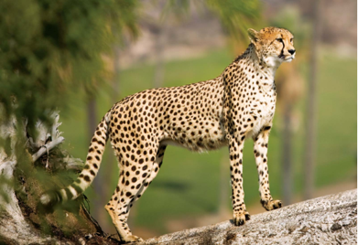
© iStockphoto/Thinkstock

Explore
Watch the video in the Video section to learn more about how cheetahs look and behave. Write down your observations on the Cheetah Observations Chart.

Extras
- Graphic Organizer: KWL Chart
- Britannica Book Club: The Cheetah’s Tale by Julia Johnson (2004)

Cheetah Observations Chart

Fill in the chart with your observations about cheetahs.

Physical Features  (what cheetahs look like) | Habitat  (where cheetahs live) | Life Cycle  (how cheetahs grow) | Behaviors  (how cheetahs act)

Fast Cats!

Complete each sentence with the correct term from the word bank.

Africa cheetahs external structures grasslands habitat

- _________________________ are the fastest land animal on the Earth.

- Cheetahs live in scattered parts of central, eastern, and southern _________________________.

- The place an animal lives is called its _________________________.

- Most cheetahs live in dry _________________________.

- All animals have _________________________ that help them survive.

Complete the chart with information about the external structures of cheetahs.

External Structure | Function/Purpose
Example  long tails | to give balance when they make quick turns

Think about what you read about cheetahs and humans. Then answer the following question.

Why are cheetahs in danger, and what can humans do to help protect them?

___________________________________________________________________

______________________________________________________________________________________________________________________________________
K  What do you know about the topic? | W  What do you want to know about the topic? | L  What did you learn about the topic?

