PROTOCOL : Ariadne’s Thread
Objective : To find the origin of the beliefs. To transform the limiting decisions.

- Define the limiting belief
- Metaphore of the thread (cable, rope…), Ariadne’s thread which represents the belief, with the 2 ends of the thread.
- P holds one end and pulls the thread towards him (like a fishing line or a wool thread – the limiting belief) which leads to the event, the origin of the belief.
- Make P describe the event (without asking for the feeling).
- If possible, P ASSOCIATES himself with the character experiencing the event at the origin of the belief and T asks the following questions :
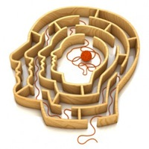
- What is the meaning given to this experience ?
- What is your opinion about the other person or people ?
about yourself ?
about your life ?
about the world ?
about the future ?
- What is the unmet need ?
- What are the decisions that you can make at that moment ?

- DISSOCIATED : take some distance, step back from this.
- What are the consequences of those decisions ?
- What other meaning can you give as an adult today ? (if no answer, bring a wise person, a mentor, a master who will propose other alternatives to interpret this event).
- Transmit to the character at the origin of this belief this new meaning and… allow the necessary time for integration.

- ASSOCIATED
- P verifies the ecology of the new belief (about one’s self, life, etc.)
- What other decisions can be made now ?

- Let P grow up with Ariadne’s thread which evolves, changes color and structure. Verify on the triggering event.

- Bridge to the future.

