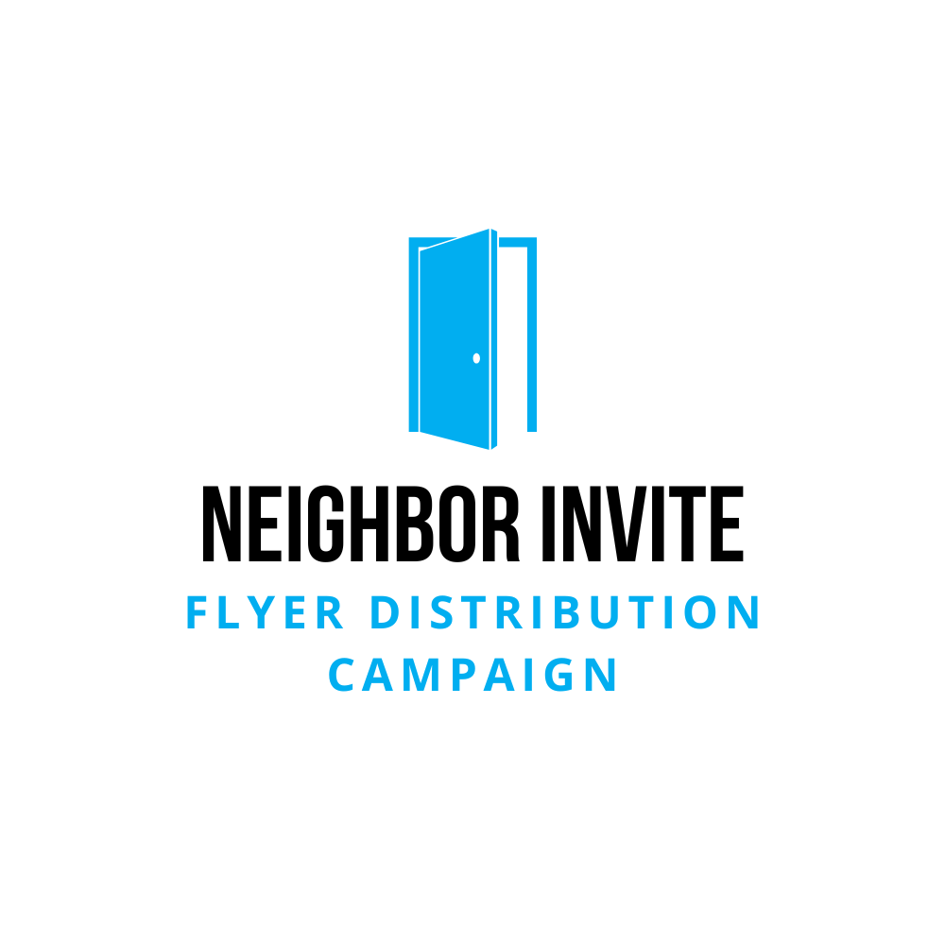 | Training Video Script

Overview
This script is designed to help individuals record a training video for the Neighbor Invite: Flyer Distribution Campaign. This video aims to motivate and equip volunteers to distribute flyers throughout their community, inviting neighbors to experience the positive impact of the local church. This resource aims to provide clear instructions, inspire participation, and remind volunteers of the deeper purpose behind this outreach effort.

Script
Introduction: "Hey there! Thanks so much for being part of this special project. We’re inviting everyone in our community to be part of what’s happening at our church. You might be wondering, why are we doing this? Well, we believe in sharing the good things happening here – people taking steps toward Jesus, families being restored, kids discovering purpose, and lives being transformed. We don’t want to keep that to ourselves – we want to extend this invitation to our whole community!"
The Big Picture: "When you go door to door, remember that you're not just handing out flyers. You’re inviting people to take a step closer to Jesus. We believe God is already at work in our community, and these flyers can be a tool He uses to spark something in someone's life. Imagine how God could use the hundred or so flyers you deliver to reach hundreds of families."
Practical Tips:
- Pray Before You Go: "Before you head out, take a moment to pray. Ask Jesus to use these flyers and guide you as you walk through the neighborhood. This isn’t just a task – it’s an opportunity for Him to work through you."
- Timing Matters: "It takes about an hour to deliver flyers to 70-100 homes, so set aside enough time. Go when it’s not too hot and be considerate of neighbors. Morning or evening is usually best. Avoid times that might disturb people, like early mornings or late nights."
- Where to Place Flyers: "Always put flyers in mailboxes. Please don’t leave them on porches, cars, or driveways. And if you see a 'No Solicitation' sign, skip that house to be respectful."
- Stay Hydrated & Be Safe: "Bring water and dress comfortably. Walking around takes energy! Also, avoid wearing headphones so you can stay aware of your surroundings and be approachable."
- Handling Conversations: "If someone asks what you’re doing, keep it simple: 'Hey, it's a flyer about some events happening at our church. Is it okay if I put it in your mailbox?' No need to have a long conversation unless you feel comfortable."
- Make it Fun: "Bring a friend or family member! My spouse and I sometimes race to see who can finish their side of the street first – it makes it more fun and goes faster. Plus, kids love helping out!"
- Be Present in the Community: "Take this time to notice your surroundings. Pray for the families in each home as you walk. This simple act can have a profound impact."
Wrapping Up: "Make sure you deliver the flyers within the timeframe given. We planned the content to align with specific events, so timing is important. When you’re done, let your team leader know how it went. We’d love to hear any stories or feedback!"
Final Encouragement: "Most of all, have fun with this! It's an honor to serve our community and invite people to something that could change their lives. Thanks for taking the time to be part of this. Even though you might feel like you’re just delivering flyers, you’re planting seeds that God can grow in amazing ways. Thank you!"

