Appeals Procedure | 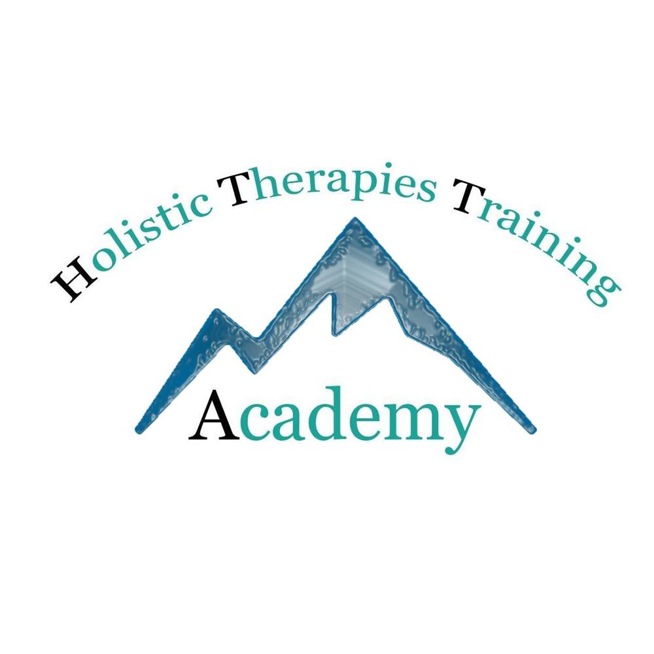

Name of centre: Holistic Therapies Training Academy

- The centre is committed to ensuring that the assessment procedure meets the requirements of the awarding organisation and fulfils national standards.

- The centre will operate a system for reviewing the quality and fairness of the assessment procedure. As part of this the learner has a right to appeal against any assessment decision, written or practical, that the candidate deems to be unfair..

- The candidate should notify the assessor of dissatisfaction with the outcome of the assessment within 7 days, stating why there is disagreement with the decision. The assessor must explain the decision in writing giving reasons, responding within 7 days.

- If the learner is not satisfied the internal quality assurer must be informed and an investigation conducted. The internal quality assurer may arrange for the candidate to be re-assessed by another assessor. The matter should be resolved in 45 days.

- If the matter is not resolved to the learner’s satisfaction, an appeal can be made to the external quality assurer, according to the awarding organisation’s appeals procedure.

It is necessary to make appeals procedure available to all learners, without the learner having to request it. It is good practice to provide the centre’s appeals and complaints procedure during the learner induction.

Those responsible within the centre are:

Name: Karen Kilminster
Name Jason Ashton
The centre agrees to comply with the appeals procedure as outlined above:

Signature: .K M Ashton Position: Lead IQA Date: 19/04/2021
Signature: J AShton Position: Lead Assessor Date: 19/04/2021

Learner Declaration:
I understand and agree to the above appeals policy.
Signature: _______________________________________ Date: _________________________
https://holistic-therapies-training.teachable.com/p/terms

