THE MORNING SERIES ~ A warm up that can be used at the beginning of a practice, or in bed upon waking.

1. Full Body Stretch
Lie on your back and, inhale, take the arms overhead, palms face up. Keep the legs together and straight. Inhale, and on the exhale, lift the pit of the abdomen and stretch up through the fingertips. At the same time, move the buttocks towards your heels. Inhale, relax the body. Exhale, stretch again. Repeat for three breaths.
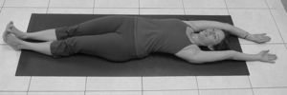

Step 1: Full Body Stretch

2. Ankle Stretch/Ankle Rotation
Continue from “Full Body Stretch” with arms overhead and breath awareness. Inhale. Exhale, point your toes away from you, and then reverse by flexing the toes back towards the face. Repeat this as many times as possible during your exhale. Inhale and relax the body. Exhale, point and flex the feet again. Repeat this for three breaths.
Inhale, exhale and rotate both ankles in clockwise circles. Inhale, relax. Exhale; repeat in the opposite direction (counter-clockwise). This is one cycle. Repeat this cycle three times, coordinating the rotation with your exhales and relaxing as you inhale.
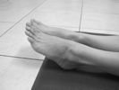

Step 2: Point then flex the feet. (Rotation not pictured)

3. Straight-Leg Twist
Continue lying on your back. Stretch your right arm out on the floor, perpendicular to your body with the palm facing up. Move your left hand to your right shoulder. With straight legs, lift your right leg and place your right Achilles tendon in the webbing between the first and second toe of your left foot. Inhale, then exhale and pull the pit of the abdomen towards the spine as you tilt your pelvis and legs to the left, bringing the toe of your right foot onto the floor on your left side. Press through both heels to keep the spine long. At the same time, rotate your head to the right and push your right shoulder down with your left hand. Inhale, come back to neutral and switch legs. Repeat on the other side during exhale.
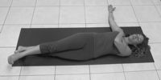
Remember, the twists are performed on exhale and changing sides is done on inhale. Remind students to continue to lengthen their spine by lifting the pit of the abdomen and pressing through the heels.
Step 3: Straight-Leg Twist

4. Bent-Leg Twist
Bend the right leg and place the foot over the straight, left leg, about six inches away from the leg. On exhale, hold the right knee with the left hand and pull it to the left, bringing the knee to the floor. Deepen the twist by rooting the right shoulder to the floor as you stretch it away from the hip. Lift the pit of the abdomen toward the head, lengthen the spine and turn your head to the right. On exhalations, twist. On inhalations, change sides. Repeat each side three times.
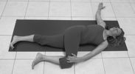

5. Knee to Chest, One Leg at a Time
Start lying on your back with your legs straight. On exhalation, bend your right knee and pull it into the chest. Clasp your leg just below the knee on the shin. With the belly soft, pull the leg into your chest and lift your head. Bring your chin towards your knee. Pull the knee toward the chest, keeping the thigh parallel to the spine, and do not pull the leg toward the center of the body. You may pull the leg toward the right armpit if there is pain in the hip. As you inhale, release the leg as your bring your head to the floor. Repeat each side three times.
Step 4: Bent-Leg Twist

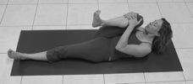

Step 5: Knee to Chest, One Leg at a Time

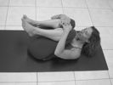6. Knee to Chest with Both Legs Together
Exhale and bring both knees into the chest, wrapping the arms around the legs and interlacing fingers to pull the legs into the chest. Bring the chin up towards the knees. Inhale and release your legs, keeping the heels off the floor as you straighten them. Once straightened, gently lower your legs to the floor. Repeat three times.

Step 6: Knee to Chest with Both Legs Together

7. Side Rolls
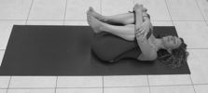Exhale and pull the knees into the chest, wrapping your arms around your legs. Keep your head on the floor but interlock your hands. Inhale, then exhale and roll to the right side and back up. Inhale to relax, then exhale and roll to the left side and back up. Repeat three times on each side.

Step 7: Side Rolls
8. Supta Padangusthasana
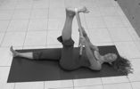With the right hand, hold onto the big toe of the right foot or place a strap around the right foot. Keep the left knee bent and the left foot on the floor. Slowly straighten the right leg. Slowly straighten the left leg as much as possible, pressing the left heel away from you as you pull the pit of the abdomen toward your head. Keep the head and right shoulder on the floor. Wait for up to nine breaths, then switch sides.
Step 8: Supta Padangusthasana

9. Return to Full Body Stretch
To complete the cycle, finish with the same pose as you started with – the full body stretch.
Step 9: Full Body Stretch

