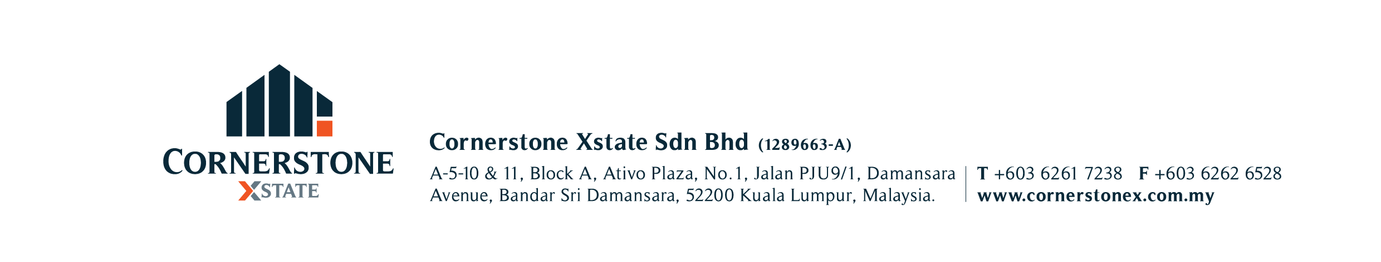

**EXCLUSIVE AUTHORISATION TO SELL CSX-AS**

I/We NRIC No. / Passport No.:

the registered/beneficial owner(s) (“the Vendor”) of the property situated and known as

(“the said Property”) do hereby appoint **CORNERSTONE XSTATE SDN BHD** (“Cornerstone”) to be my/our **EXCLUSIVE AGENT** for a period of six (6) calendar months, commencing from the day of 20 and expiring on the day of 20 ­­_________

(“Exclusive Period”) for the sale of the said Property to any Purchaser(s) at the selling price of RM

(Ringgit Malaysia Only) or the nearest offer to be agreed by the Vendor (“The Purchase Price”) upon the following terms and conditions: -

1. In consideration of Cornerstone providing the service for the sale of the said Property, the Vendor hereby agree(s) to pay a professional fee (“the said Fees”) equivalent to 3% of the Purchase Price plus Sales and Services Tax (“SST”), on the said Fees upon the happening of any of the following events: -

* 1. During the Exclusive Period, Cornerstone procures or secures a purchaser(s) on the terms specified herein, the said Fees and SST being payable upon the execution of the formal Sales & Purchase Agreement (“SPA”); or
  2. During the Exclusive Period, the said Property is sold or contracted to be sold by the Vendor personally or through other agent/person(s) other than Cornerstone; or
  3. During the Exclusive Period, this authorisation is revoked by the Vendor willfully or by persistently obstructing Cornerstone from performing its obligations hereof; or
  4. After the expiry of the Exclusive Period, the Vendor entered into SPA with a purchaser(s) who was introduced, sourced, secured or procured by Cornerstone prior to the expiry of the Exclusive Period.

2. This exclusive authorisation shall be considered as renewed for a period equivalent to the original term unless it is terminated in writing by either party. The extended exclusive period shall expire at the end of the extended term unless it is renewed by the parties hereto by mutual consent upon new terms and conditions to be agreed between parties.

3. Cornerstone is hereby authorised to accept and receive on behalf of the Vendor an Earnest Deposit of 2.0% to 3.5% of the Purchase Price (“Earnest Deposit”) as Stakeholder and is authorised to deduct the said Fees and SST from the Earnest Deposit before releasing the balance, if any to the Vendor.

4. In the event the Earnest Deposit has been paid and the sale transaction is aborted by the Vendor or the Purchaser(s) before the execution of the SPA, the Vendor agrees to pay a fee equivalent to 50% of the Earnest Deposit or forfeitable deposit or 50% of the said Fees, whichever is less together with SST thereon.

5. The Vendor agrees to indemnify Cornerstone against all losses and damages claimed by the Purchaser(s) if the Vendor for any reasons whatsoever, does not proceed to execute the SPA after the Earnest Deposit has been paid or collected.

6. The Vendor hereby authorises Cornerstone to put up a “FOR SALE” signboard at the said Property and advertise in any media or in any other forms/activities to promote the sale of the said Property.

7. This instruction is given to Cornerstone in the Landlord’s capacity as the: -

* 1. Registered proprietor or beneficial owner of the said Property; or
  2. Attorney of the owner of the said Property under the Power of Attorney dated ; or
  3. Personal representative (Executor or Administrator) of the owner (deceased).

8. Terms and Conditions of sale transaction: -

a) 10% of the Purchase Price to be paid by the Purchaser(s) upon the execution of the SPA;

b) 90% of the Purchase Price to be paid within three (3) months of the execution of the SPA OR date of receipt of the relevant consent from the Statutory Body/Developer’s Consent/Developer’s Confirmation/FIC/State Authorities/Extract of LA/Extract of Grant /Extract of the court order for sale, whichever is the later and applicable, failing which a further One (1) month may be granted to the Purchaser(s) to enable him to settle the balance sum PROVIDED that interest shall be chargeable on the unpaid balance at __________ % ( percent) per annum calculated on a daily basis.

9. The Vendor hereby declares that he/she/they is/are the registered/beneficial owner(s) of the Property and not bankrupts.

SIGNED BY THE VENDOR AND/OR (FOR AND ON BEHALF OF CO-VENDOR) SIGNED IN THE PRESENCE OF

NAME : NAME :

ADDRESS : NRIC NO. :

DATE :

CONTACT NO. :

E-MAIL :

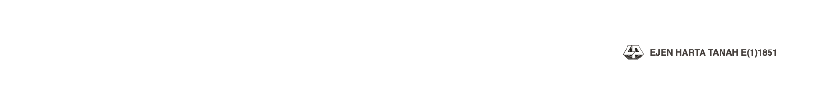

NB : ALL PRACTICES WILL BE IN ACCORDANCE TO THE VALUERS, APPRAISERS AND ESTATE AGENTS (AMENDMENT) RULES 2002