ATTACH THESE PAGES AFTER THE WORKBOOK FROM THE
CONDUCT A STRATEGY ANALYSIS COURSE

^{v1.0}

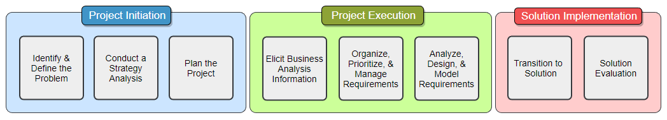
The BA Guide’s Business Analysis Process

Plan the Project Process

Important Concepts
Project Manager vs Business Analyst:

Adaptive Methodologies vs Predictive Methodologies:

Key Terms
Project -

Stakeholder -

Requirements -

Project Plan Initiation

The Basics

Goal:

Step 1:
Step 2:

Step 3:

Stakeholder Identification
Types of stakeholders could include…

Why identify stakeholders? How to identify stakeholders?

Project Charter

Project Charters are utilized to:

Notes:

Arrange a Kickoff Meeting

What is a kickoff meeting?

Arranging a kickoff meeting:

It is important for project team members to be able to attend the kickoff meeting.

Conduct a Kickoff Meeting

Steps to Conduct a Kickoff Meeting:

Notes:

Requirements Management Plan

Requirement Abstraction

Abstraction refers to the of a requirement.
Notes:

Ultimate Question:

Requirement Storage and Access

Defines where requirements will be and how stakeholders will them.
Formats and Storage:

Things to consider:

Ultimate Question:

Requirement Attributes

Attributes describe the metadata; the about the data.
Notes:

Typical Adaptive Attributes: Typical Predictive Attributes:

Ultimate Question:

Requirement Reuse

Requirement reuse is the concept of reutilizing project requirements in .
Notes:

Ultimate Question:

Requirement Traceability

The ability to a from the original source through deployment.
Benefits of Traceability:

Common Traceability Techniques:

Ultimate Question:

Requirements Change Control
Allows for projects to remain to ever changing business needs while also taking into consideration the of the requested change.
Adaptive Change Control:

Predictive Change Control:

Ultimate Question:

Requirements Approval Process
Define and requirements are approved by project stakeholders.
Ensure that requirements:

Adaptive Notes:

Predictive Notes:

Ultimate Question:

Project Plan Details

Break Down the Project

Divide the project into to help define how the work with be performed.
Projects can be divided into or .

Chart Mind Map Outline

Break Down the Project (continued)

Steps to Break Down the Project:

Adaptive Notes:

Break Down the Project (continued)

Predictive Notes:

Set the Project Schedule

A signifies an important event in the project.
Project Milestone Notes:

S__________________

T__________________

A__________________

R__________________

M_________________

Set the Project Schedule (continued)

Estimation is the concept of predicting the of .
Estimation Notes:

Adaptive vs Prediction Estimation:

Set the Project Schedule (continued)
Adaptive Estimation Techniques:

Set the Project Schedule (continued)
Predictive Estimation Techniques:

Set the Project Schedule (continued)

A is the constraint between two activities where one activity

is reliant on the other being completed, or at least started.
Notes:

Set the Project Schedule

Setting an Adaptive Schedule:
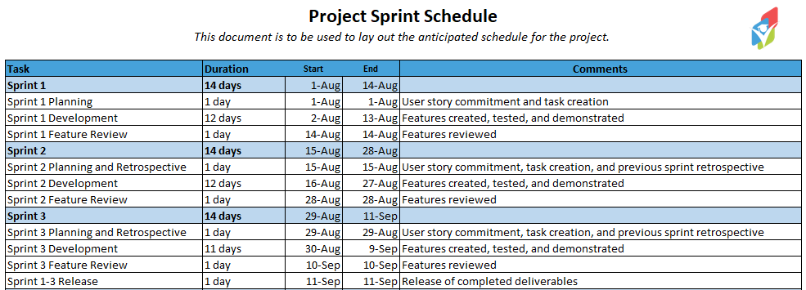

Set the Project Schedule

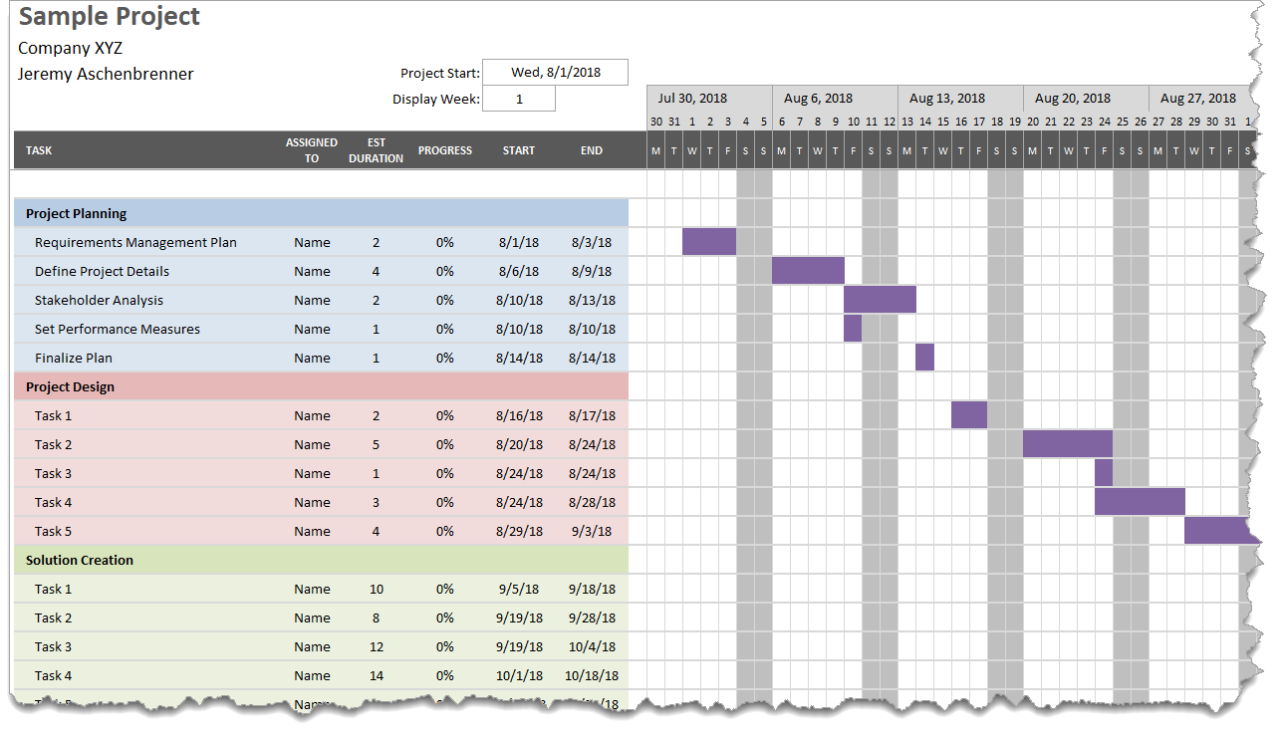
Setting a Predictive Schedule:

Define a Quality Plan

Outlines the quality , , and quality assurance mechanisms for a project.
Testing and Quality Assurance Notes:

Defect Management Notes:

Training Requirements Notes:

Release Planning

Formulate a plan to begin using project in a production environment.
Adaptive Release Planning Notes:

Release Planning

Predictive Release Planning:
Plan how…

Rollout Options:

Support Considerations:

Details to Hand Over:

Stakeholder Analysis and Engagement

Stakeholder Power Interest Analysis
Utilize a stakeholder’s and to appropriately involve them in the project.
Notes:
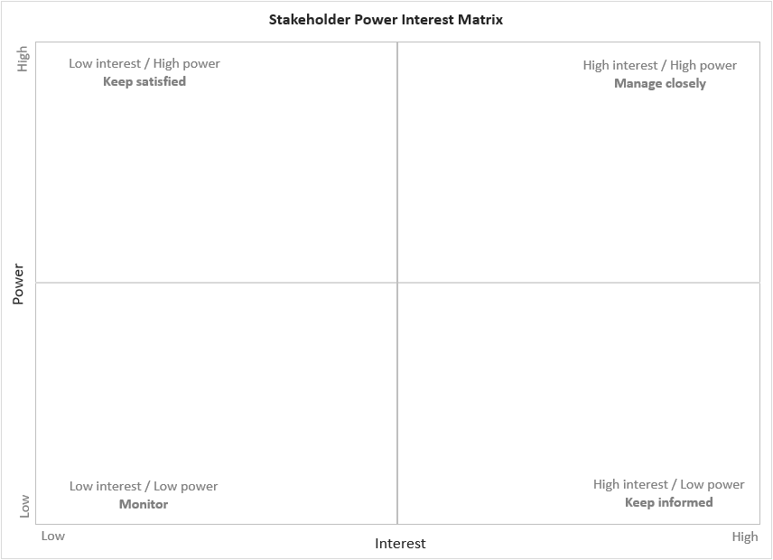

RACI Matrix
RACI Matrix helps to align the of stakeholders to project .
Notes:

I__________________

R__________________

A_________________

C__________________

Validation:
- At least one person is per task
- At least one person is per task

Responsibility Assignment Matrix

Notes:

P__________________

S_________________

A__________________

Collaboration and Communication Plan

Provides guidance on the needs for the project.
Notes:

Project Performance Measures

Steps to Complete:

Notes:

Notes:

Business Analysis Performance Measures

Measurables help to:

Steps:

Notes:

Notes:

Notes:

CONGRATS ON COMPLETING THE
PLAN THE PROJECT COURSE!

Find more courses in this Business Analysis Process Series at:
www.thebaguide.com/baprocessseries

