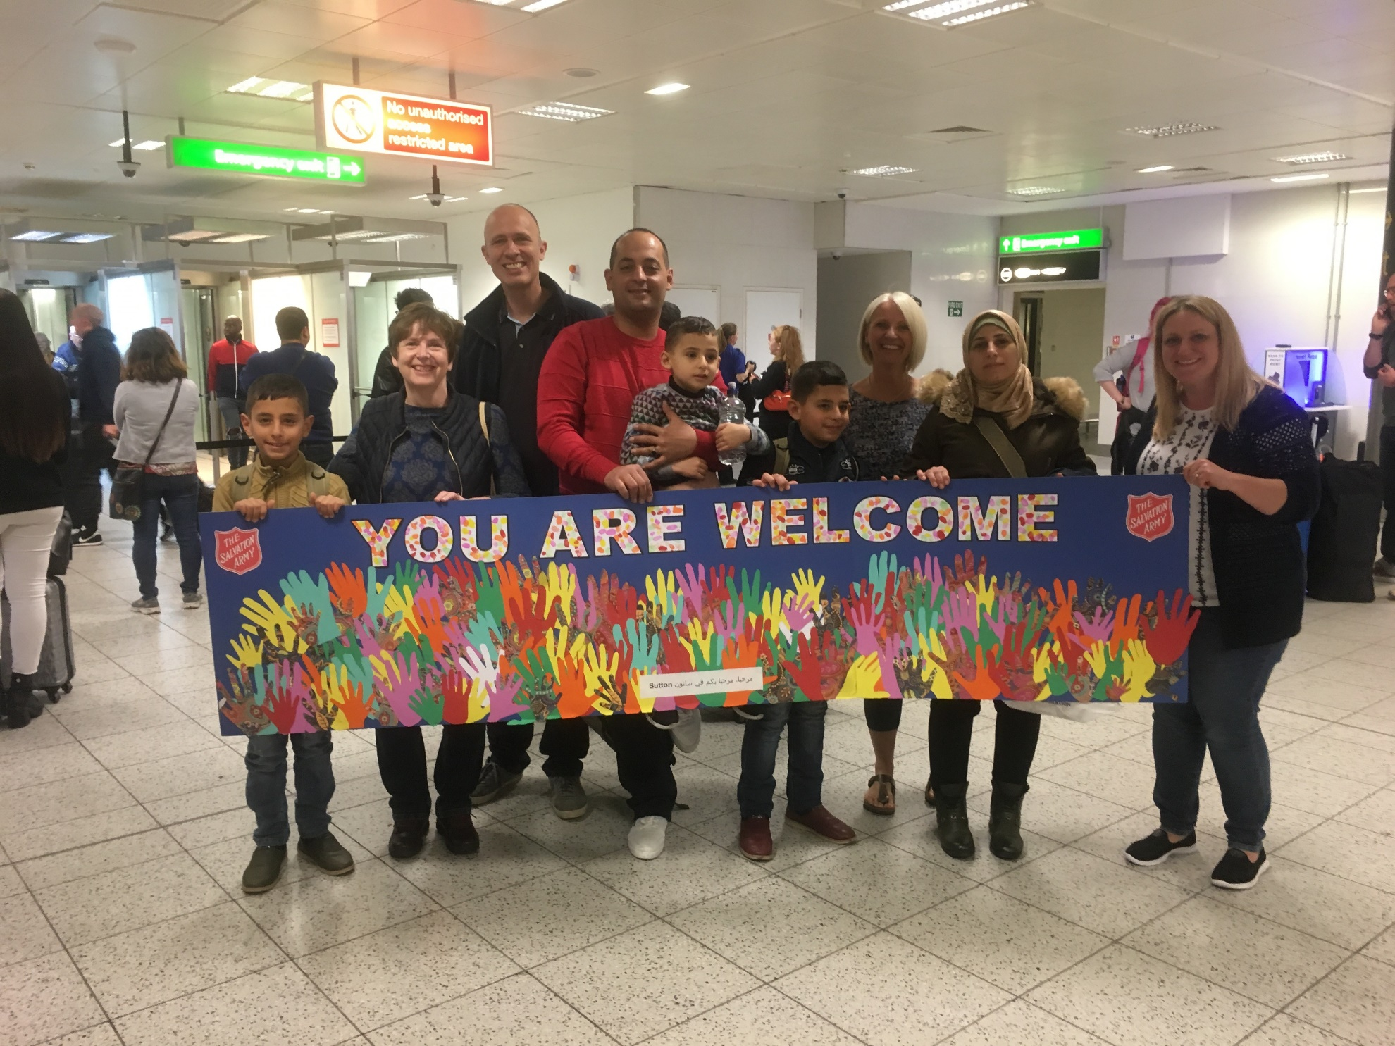
Defining Boundaries: A Guide for Community Sponsorship Groups

Contents
Introduction: Why Do We Need to Define Boundaries? 3
Step One: Defining the Volunteer Relationship 3
Step Two: Define Safe Practices 5
Your Personal Safety 5
Planned activities with the family 6
Hospitality, gifts and money 7
Communication 7
Advice and Decision Making 8
Maintaining Positive Relationships 9
Social Media and Photographs 9
Confidentiality 9
Step Three: Write a Code of Conduct 10
Step Four: Briefing your family 10
Appendix One: Code of Conduct Example 11
This guidance has been created to help Community Sponsorship groups to think about the volunteer relationship. It provides practical guidance for defining safe boundaries, to prevent putting volunteers or families at risk.

Introduction: Why Do We Need to Define Boundaries?
Spending time defining the way in which your Group will operate and what your family can expect from you will be hugely helpful; for your Group as well as the family.
Boundaries help protect volunteers and the family by clarifying what type of behaviour is, or is not, acceptable. This helps people to have confidence about how to act in different situations, encouraging high standards and consistency between different volunteers. This helps manage expectations and prevent misunderstandings. Boundaries also help everyone to preserve their privacy and manage self-care.
Good boundary setting at the beginning helps ensure healthy and sustainable relationships for the future.

Step One: Defining the Volunteer Relationship
It is important to consider the distinction between being a friend, and volunteering. Friendship is a private mutual relationship. As a volunteer with a Community Sponsorship Group, you are providing a service which is open to scrutiny by others.
The overall aim is to form good relationships with any member of the family you are supporting, in order to assist them to
- Become familiar with their new surrounding
- Settle, live and work independently in the UK, and
- Learn English
You are here to provide support to the extent that the family wants and needs it, to help ensure that Home Office requirements regarding language learning, education, employment support, health support are met, to promote the family members’ wellbeing and encourage their independence.
Being clear about your role is an important part of working safely

Write clear volunteer role descriptions
Create a volunteer role description for each person. It can be simple, but it should outline what they are expected to do, and what experience or skills they need.
This will help to set boundaries about what support each person you will or will not offer.
It will also help you to know when you have completed your volunteer role and are ready to transition from a formal volunteer to an informal friendship.
Don’t be afraid to clarify boundaries if the family ask you to do something which is not your role.
Bear in mind that the family may have limited understanding of the volunteers’ role, and may have unrealistic expectations about what may be offered. Try to be clear from the outset about the boundaries of your role. For example, you are not expected to be on call at any time day or night, or to carry out household tasks or errands, and you will not be providing childcare or activities solely with children; children remain the responsibility of their parents at all times.

Transitioning from volunteer to friend.
One of the great things about Community Sponsorship is the lasting friendships created in the local community. However, we also know that Groups find the transition and boundaries between being a volunteer and being a friend one of the most difficult areas to manage.
Volunteers offer a commitment of time, to fulfil a role. Once that role is complete, or no longer needed, the volunteer role can end, and friendship can begin. It is important that you make this a formal process, so that everyone is clear when the volunteer relationship has ended. Transitions may be difficult for some volunteers and families, so a debrief and monitoring will be important.
You will need to be flexible and adaptable but try to make the transition part of the wider plan.

Empowering People to Live Independent Lives
Your purpose is to empower families to live independent lives. Since you are dedicating your time to this project, it is likely that you care very deeply about supporting people. This is brilliant, but it is important that your compassion doesn’t lead you to doing things for the family, rather than guiding them to solve problems themselves, and to build the skills they need to live with autonomy and resilience. At Citizens UK, we advocate the ‘Iron Rule’:

Never do for others what they can do for themselves.
Follow these principles of empowerment:
- Empower families to make their own choices.
- Provide families with enough information to make informed decisions.
- Encourage families to be independent.
- Support their decisions – whether or not you agree with them

What does that mean for you?
- Families will make decisions for themselves and set their own goals they work towards.
- You work in partnership with families – they are not dependent on you.
- Sometimes, families will make decisions you disagree with and sometimes they will make mistakes.
- Some people may need more encouragement than others.
For more information about empowering you families, visit the Reset website - https://training-resetuk.org/toolkit/working-with-refugees/empowering-refugees

Step Two: Define Safe Practices
Before the family arrives, you should work together as a team to decide what your boundaries are. Look at each of the areas outlined in this guidance and agree together what is acceptable.
Remember, you will all have different knowledge and experience, so you may have different points of view about what is and is not acceptable. What is important is that you agree, as a Group, what the Groups boundaries are, so there is consistency across the team.

Your Personal Safety
 | Sponsor Refugees Advice | Our Notes
Prioritise your own safety | Always prioritise your own wellbeing, health and safety.  If you are concerned about anyone’s behaviour, or you feel at risk, you under no obligation, and should NOT remain in a situation you consider unsafe.
Let others know where you are. | When you visit the family, let someone else know where you are going and when you expect to return.
Mobile phones. | Take a charged mobile phone with you in case of emergencies
Alcohol, Drugs and Cigarettes | Do not visit the family while under the influence of drugs or alcohol.  Do not smoke in or around the family home.
Report concerns to DSO | Report any health and safety concerns or incidents (even minor incidents or ‘near misses’) to the Designated Safeguarding Officer

Planned activities with the family
 | Sponsor Refugees Advice | Our Notes
Two-person rule. | In the initial support stages, it is always safer to make sure there are two people present when meeting families. This protects both you and the family from potential harm, or allegations of harm.
Lone working. | You might decide, once a relationship has been established with the family, to allow lone-working. This decision should be made as a group, and with the express consent of all volunteers and family members.  When making this decision, think about what the risks might be, how to minimise these, and what to do if something goes wrong.  No-one should be asked to be alone with a volunteer/family member if they feel uncomfortable.  Some groups decide that no male family member and female volunteer, or vice versa, will be alone together throughout the sponsorship period.
Public places. | We encourage you to organise activities in public or community places so families can get out into the community.  Their home is a private space, and wherever possible, it should be protected as such.  Make sure the places you use are appropriate, free, and not a complete culture shock.
The family home. | Once the family is living in the home, volunteers and other Group representatives should not visit their home without an appointment or invite.
Invites to your home. | Inviting the family you are supporting as a volunteer to your home or other private location can blur the boundaries between your volunteer role and potential friendship.  It could also put unfair expectations on other volunteers, who may not feel comfortable or able to host people in their home.  It may also bring to light socio-economic differences between you and the family, which could lead to friction or difficult conversations.  We suggest that volunteers should only welcome families into their homes once they have stopped being a volunteer.  Any other instance (for example, if you are an English language teacher, and you have an office or studio where you teach) should be part of a pre-arranged activity, discussed with agreement from the family and the leadership team.  A risk assessment should be carried out, to consider what the risks could be and how to prevent these.

Hospitality, gifts and money
 | Sponsor Refugees Advice | Our Notes
Gifts. | The family will be living on a very tight budget. They may feel obliged to feed you each time you visit, or show their gratitude through gifts, but this could get very expensive very quickly.  It is easiest to agree not to accept any gifts from family members and avoid accepting hospitality beyond a token amount. Talk to the family about what they would normally expect to do and explain what you will accept and why.  Don’t give gifts to family members. This can lead to unrealistic expectations of you and the other volunteers. Discuss with the leadership team if you wish to offer a gift or to reciprocate hospitality.
Money. | Don’t lend to or borrow money from any person you are supporting. Be clear that it is the family members’ responsibility to manage their money and make decisions about what they spend; you are not responsible if they are struggling with this, but can bring concerns to the attention of the group.
Trips. | Be mindful that the family will need to manage within the resources available to them; if you suggest outings or shopping trips, ensure that these will be affordable to the family

Communication
 | Sponsor Refugees Advice | Our Notes
Have clear times for communication. | Decide times of day that you can be contacted for non-emergencies (e.g. between 8am to 9pm) and communicate this clearly to the family.  Ask the family what times of day they are happy to be contacted also.  If possible (once things have settled), organise a regular, scheduled visit time, where you will troubleshoot problems that arose that week and make plans, so that you can all protect and manage your time.
Main contacts. | Assign key volunteers to be the main contact point.  If you feel you need to share your contact details, or have the contact of someone you are supporting, the leadership team and family should approve this.
Private contact. | There is no need for volunteers to have any private contact with the family which is not part of their volunteer role.

Advice and Decision Making
 | Sponsor Refugees Advice | Our Notes
Making Decisions. | Empower families to make their own choices.  Provide family members with the information they need to make informed choices.  Don’t let your personal opinions interfere with supporting the family in their chosen course of action.
Empowerment. | Never do for others what they can do for themselves.
Refer to specialist organisations or individuals | It’s not safe to give families specialist advice outside of your knowledge (e.g. immigration, healthcare, legal).  You should signpost them to people and organisations best placed to give them professional advice.  NOTE: Giving immigration advice if you are not an OISC regulated adviser is a criminal offence.

Maintaining Positive Relationships
 | Sponsor Refugees Advice | Our Notes
Respect | Respect differences in beliefs, religion, culture, and so forth. Do not try to impose your beliefs on others.
Reliability | If you’re unable to attend a planned visit, give as much notice as possible. Although events can happen that are beyond your control, the person you are supporting may feel very let down. Avoid taking on too much and risk letting people down.
Be positive and professional | Never collude with the family’s negative comments about other volunteers and other family members.

Social Media and Photographs
 | Sponsor Refugees Advice | Our Notes
Photographs. | Only record images when you have the consent of everyone involved.  Be considerate about how the photographs will be stored and shared.
Social Media. | Don’t ‘friend’ any family members on social media or similar while you are a volunteer. This blurs the boundaries of your role.  Don’t post images or share information about the family on social media without their consent.

Confidentiality
 | Sponsor Refugees Advice | Our Notes
Confidentiality. | It is never acceptable to discuss personal information about volunteers or the family without their express permission, except where withholding such information could lead to harm, or where an illegal activity is being carried out.
Avoid sharing information informally | Avoid talking about confidential information or making casual comments about individuals in informal or social settings, including with your own family or friends.  You should also take care when speaking to a person about a confidential matter in a public place.  Speak about people as though they are in the room with you.

Step Three: Write a Code of Conduct
Once you have defined your boundaries and safe practices as a group, write a Code of Conduct. Every volunteer and family member should agree to and have a copy of this code.
A Code of Conduct helps the family and volunteers know how they can expect you to behave, and how they can expect you to behave. It is useful when you have to explain why you can or cannot do something.
Also, if you have concerns about a volunteer or family member’s behaviour, it helps to frame your conversation and remain objective.

See Appendix One for an Example Code of Conduct.

Step Four: Briefing your family
Making sure your family understand your boundaries is also important. You will probably give your families a welcome briefing, but it will be an emotional time for them and there is a lot of information they may not remember. Therefore, each volunteer should remind the family what their role is when they meet.
Go through your Code of Conduct together and ask the family if they would like to add or amend any points. It may be useful to frame the conversation in a way that seeks to understand what would be normal or acceptable for them. For example, “How would you expect to communicate on a day to day basis with us?”.
Boundaries may need to be renegotiated if the relationship with the family changes, or if the boundaries you have set are not practical now your family has arrived. Make sure that any changes are communicated to all volunteers and family members and that everyone agrees to follow them.
Remember:
• Explain why the boundaries have been set in an honest and open way. They may not understand why you are trying to be more ‘professional’ in your approach.

• Discuss your boundaries with the family. Give them the opportunity to ask questions, add or amend any points.

• Don’t be afraid to clarify boundaries if the family ask you to do something which is not your role. They have a lot of information to remember and may forget.

• When the role changes, help families understand what has changed, why and what that means.

• Make sure families know how to raise any concerns they may have about volunteers.

Appendix One: Code of Conduct Example
Add an introduction to your group – who are you?
We are all volunteers. We are not paid by the government or any NGO. Our role is to provide support to the extent that you want and need it. We are doing this because [What motivates us to support the family?]
We will support you for 12 months from DATE to DATE.
We will help you to:
- Become familiar with your new home;
- Settle, live and work independently in the UK, and
- Learn English

Your Commitment
We expect you to:
- Be kind and considerate. Please remember that we are volunteers, and we are not paid to support you.
- Treat us with respect and equality. Respect our beliefs, gender, religion, culture, ability, sexuality, and experience. Do not impose your beliefs on others.
- Don’t get drunk, smoke near to, or consume drugs while we are visiting.
- Don’t put us in physical danger
- Don’t act sexually inappropriately
- Contact us between Xam and Xpm, unless it is an emergency
- If we have an arranged appointment, please be on time.
- If you are unable to attend a planned visit, give as much notice as possible. We may have arranged our work and other plans around this appointment.
- Feel comfortable to say ‘no’ if you disagree with us.

Our Commitment to You
In return, we pledge the following commitments.

We will respect you.
- We will be kind and considerate
- We will respect your beliefs, gender, religion, culture, ability and experience. We will not impose our beliefs on you.
- We will not act sexually inappropriately
- If we can’t attend a planned visit, we will give you as much notice as possible.

We will respect your autonomy.
- We will not do things for you – we will help and teach you, so that you have power to do things for yourself.
- We will try to give you enough information to make informed choices
- We will empower you to make your own decisions
- We will support your decisions

We will respect your privacy.
- We will not visit your home without an appointment or invite.
- We will not share your contact details without your permission – only a few designated group members will know your telephone number.
- We will not discuss personal information about you without your express permission (except where withholding such information could lead to harm).
- We will not make casual comments about you in informal settings – for example, to our friends and family.
- We will only contact you between hours of X and X, unless there is an emergency.
- We will not take or share photographs of you without your consent.
- While we are volunteers, we will not “friend” you on social media.

We will not exchange gifts or money
- We do not want you to feel obliged to give us food/drink every time we visit, or to spend your money on us. So, we won’t accept gifts or hospitality from you, beyond a very small gesture.
- We won’t lend to or borrow money from you. If you have concerns about money, tell us, and we can help you to find solutions.

We will work safely
- We will make sure that all volunteers are checked and safe
- Initially there will always be two volunteers present when we meet with you
- We will not volunteer while under the influence of drugs or alcohol. We will not smoke cigarettes around you.
- We will not put you in physical danger
- We cannot give you specialist advice (this is illegal in the UK). If you need such advice, we can help by connecting you with professional immigration lawyers.

What to do if you are concerned or have a complaint?
- If you are concerned about anyone’s behaviour, or you feel at risk, you should NOT remain in a situation you consider unsafe. You can ask a volunteer to leave at any time.
- If you have a complaint or concern about the conduct of a volunteer, it is best to start by speaking with the person directly involved.
If you cannot resolve your complaint or concern this way then contact: NAME AND CONTACT
- Or, if your complaint is about NAME, or you are not happy with how they have treated your complaint, you can contact: NAME and CONTACT

- Our Complaints Policy (ATTACH) details how we will respond to your complaint.

What to do if we are concerned or have a complaint?
- If a volunteer is concerned about someone’s behaviour, or feels at risk, they must NOT remain in a situation they consider unsafe.

- If a volunteer has a complaint or concern about the conduct of a family member, they should start by speaking directly with the person and try to resolve informally. They should tell the Core Team about the discussion.

- If the volunteer cannot resolve the problem informally, or if the Core Team decide that there has been a breach of the Code of Conduct, the Core Team will work with the persons involved to resolve the problem. Steps to resolve may include:
  - A written apology
  - A mediated discussion
  - Cultural awareness workshop

- Where complaints or concerns remain unresolved, the Core Team will contact the Home Office for advice and mediation.

- All people will remain confidential, telling only people who need to know.

- Once the concern is closed, the Core Team and family members will review the Code of Conduct and decide whether any amendments are needed.

All volunteers must: - Have an enhanced DBS Check (This means that we have checked their police records to ensure they do not have a criminal history of violence or abuse). - Provide two references (This means that two people have written a statement to declare they know the volunteer to be a trustworthy person). - Attend safeguarding training (this means they know how to keep you and themselves safe).

